DEEP-LEARNING BASED VEICHLE COUNT AND FREE PARKING SLOT DETECTION

AJAY JAIN

Final Thesis Report

MARCH 2024

# DEDICATION

I am deeply thankful to my parents and wife for their unwavering support and Mr. Kapil invaluable guidance throughout my research journey. Their expertise, insightful feedback, and constant encouragement have played a pivotal role in shaping the outcome of this work. Additionally, I extend my sincere appreciation to the dedicated team at Hewlett Packard Enterprise for their steadfast commitment and collaborative efforts throughout this endeavor.

Their contributions have been instrumental in advancing the progress of the project and achieving our collective goals. Together, their support network has provided the foundation upon which I have been able to navigate challenges, overcome obstacles, and ultimately realize the success of this endeavor. This journey has not only been one of academic and professional growth but also a testament to the power of teamwork, resilience, and unwavering support.

I am profoundly grateful for the opportunity to work alongside such remarkable individuals who have enriched my research experience and contributed to its overall success.

# ACKNOWLEDGMENTS

I extend my deepest appreciation to my parents and my wife for their invaluable guidance and unwavering support throughout my research journey. Their expertise, insightful feedback, and encouragement have played a pivotal role in shaping the outcome of this work. I am also grateful to my dedicated team at Hewlett Packard Enterprise, whose collaborative spirit and assistance in sharing the workload have greatly enriched my academic pursuits. Their camaraderie and cooperation have enhanced my overall experience.

I am profoundly thankful to my brother, whose steadfast support has been a constant source of strength throughout this journey. His encouragement and understanding have made this research endeavor not only possible but also immensely fulfilling.

Furthermore, I express my gratitude to all those who have contributed, no matter how small, to supporting me during this endeavor. Your encouragement has been a driving force, and I am genuinely appreciative of the collective effort that has contributed to the successful completion of this research.

# ABSTRACT

Intelligent parking systems are designed to reduce fuel consumption and enhance traffic management by accurately monitoring vehicle entries, exits, and identifying unoccupied parking spots. Leveraging optical streams from cameras eliminates the need for additional sensors in parking areas. We propose a novel technique based on Faster R-CNN to identify and detect vehicles, specifically aimed at identifying spaces for parking. Deep segmentation features are employed to precisely compute the number of automobile entries and exits.

To validate the effectiveness of our approach, we conducted extensive evaluations using the PKLOT dataset, a widely recognized benchmark dataset for parking lot analysis. Our findings demonstrate a notable 8% increase in precision compared to existing methods, underscoring the efficacy of our proposed technique in accurately identifying parking spaces.

Looking ahead, this innovative approach holds immense promise in revolutionizing the landscape of intelligent parking infrastructure. By creating more efficient and resource-conscious parking systems, we envision a future where urban mobility is seamlessly integrated with sustainability goals, ultimately leading to enhanced quality of life for all the stakeholders.

# TABLE OF CONTENTS

DEDICATION II

ACKNOWLEDGEMENTS III

ABSTRACT IV

LIST OF TABLES VIII

LIST OF FIGURES IX

LIST OF ABBREVIATIONS X

CHAPTER 1: INTRODUCTION 1

* 1. Background of the Study 1
  2. Problem Statement 2
  3. Aim and Objectives 3
  4. Research Questions (IF ANY) 3
  5. Scope of the Study 4
  6. Significance of the Study 4

CHAPTER 2: LITERATURE REVIEW 5

* 1. Introduction 5
  2. Related Research 7
  3. Advancements in Computer Vision and Image Recognition 10
     1. Convolutional Neural Network Techniques 15
     2. Region Based CNN (R-CNN) 16
     3. Faster R-CN 17
     4. Mask RCNN 18
     5. YOLO 18
     6. Neural Networks 20
  4. Research Gap 20
  5. Process Model 21
  6. Summary… 22

CHAPTER 3: RESEARCH METHODOLOGY 23

* 1. Introduction… 23
  2. Research Design 23
  3. Business Understanding 24
  4. Data Understanding 24
  5. Data Collection and Preparation 25
  6. Modelling 25
  7. Evaluation 25
  8. Deployment… 26

CHAPTER 4: ANALYSIS , DESIGN AND IMPLEMENTATION 27

* 1. Introduction… 27
  2. Attribute Selection… 27
  3. Analysis of Testing Data 29
  4. Modeling… 29
  5. Implementation 34
  6. Prototype Evaluation 34
  7. Summary 35

CHAPTER 5: RESULTS AND DISCUSSION 35

* 1. Introduction 36
  2. Model Output 35
     1. Object Detection and Classification Using YOLO Algorithm 36
     2. Mask R- CNN in identifying and categorizing objects 37
  3. Discussions 39
  4. Summary 42

CHAPTER 6: CONCLUSIONS AND RECOMMENDATIONS 43

* 1. Conclusions .44
  2. Contributions 44
  3. Future Work 44

REFERENCES 45

APPENDIX A: RESEARCH PLAN…………………………………………………………..…53

APPENDIX B: RESEARCH PROPOSAL …………………………………………………..….54

.

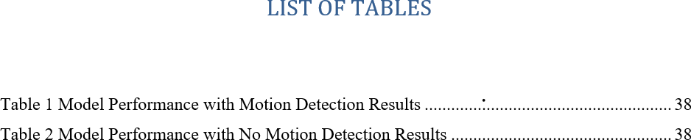

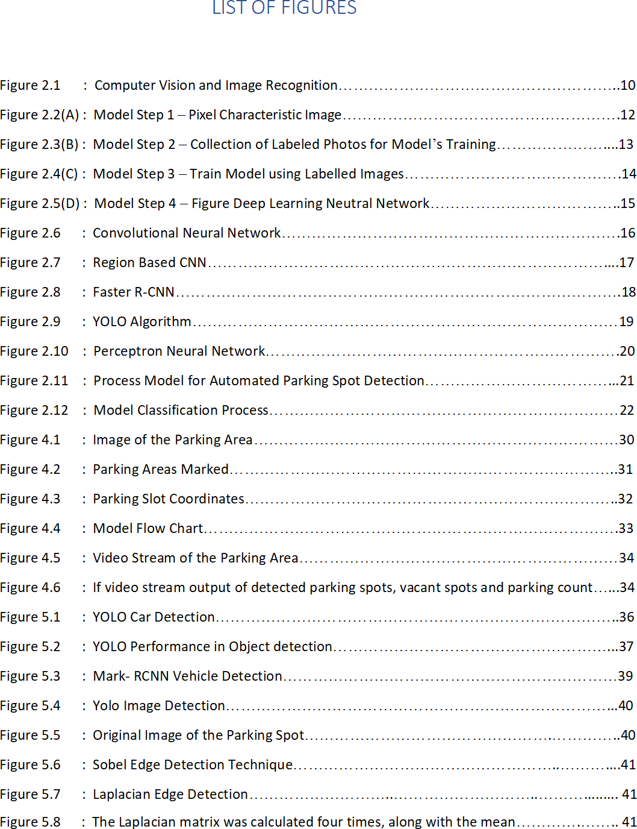

LIST OF ABBREVIATIONS

|  |  |
| --- | --- |
| YOLO | You Only Look Once |
| SVM | Support Vector Machines |
| CNNs | Convolutional Neural Networks |
| RCNN | Region Based Convolutional Neural Networks |
| F-RCNN | Fast - Region Based Convolutional Neural  Networks |
| RMRCNN | Refined Mask Region Based Convolutional  Neural Networks |
| OCR | Optical Character Recognition |
| CV | Computer Vision |
| ML | Machine Learning |
| AI | Artificial Intelligence |
| MRCNN | Mask Region Based Convolutional Neural Networks |
| PKLOT | Parking Lot |
| GUI | Graphical User Interface |

# Background

**CHAPTER 1 INTRODUCTION**

In the recent years, Time and Finances are crucial to everyone’s daily life, irrespective of their professional domain. Technological innovation offers the potential to effectively manage both these crucial variables. The world's population is growing, leading to more people living in cities instead of rural areas that causes more traffic. **Traffic jams are a big problem now because there are more and more vehicles on the roads every day , but not enough parking spaces for all of them (Amato, G., Carrara, F., Falchi, F., Gennaro, C. and Vairo, C., 2016).** According to research conducted by Our World in Data, urban areas presently house half of the global population. Smart cities, which use technology to make things like restaurants, stores, entertainment, and sports better, are still new and are not growing as fast as cities themselves.

In major cities, there is a shared preference among residents for a centralized hub that caters to all necessary extracurricular activities. Strategic placement of businesses in key locations within shopping centers becomes essential, capturing customers' attention and potentially boosting sales. Presently, shopping centers offer a range of services, including banks, food courts, leisure facilities, movie theaters, and playgrounds, consolidating various services in one central area to address the diverse needs of visitors. .

**The availability of sufficient parking space is a critical consideration, especially for gatherings involving people from diverse geographical backgrounds. 30 percent of traffic jams mostly caused by the drivers to detect the space for parking** **(H. Bura, N. Lin, N. Kumar, S. Malekar, S. Nagaraj, and K. Liu., 2018).**  **Smart parking could save considerable amount of fuel if it is implemented properly and used according to the planning of cities and urban areas which are densely populated (P. R. de Almeida, L. S. Oliveira, A. S. Britto, E. J. Silva, and A. L. Koerich., 2015)**. Adequate parking is crucial for personal vehicles, and shopping centers often provide parking spaces. The swift, secure, and reliable availability of parking spaces is directly correlated with increased customer frequency and spending, making it more convenient for drivers to locate available parking spaces.

The management of vehicles and parking is facilitated by the size of the parking lot, allowing workers to easily identify unoccupied spots.

The implementation of parking vacant detection techniques serves various purposes, including autonomous automobile parking, traffic alleviation through quicker identification of available parking spaces, and optimization of customer parking space allocation. Contemporary algorithms utilize typical machine learning techniques to segregate parking lots, with sensors being a prevalent method in literature to locate open parking spaces. Some studies employ Support Vector Machines (SVM and background removal methods to categorize patches as either empty or occupied.

The recent trend involves an increased reliance on deep convolution neural networks, capitalizing on deep learning breakthroughs in recent years. Proposing a straightforward resolution, the use of object detection techniques within deep learning holds promise for the development of practical and intelligent bay infrastructure.

**1.2** **Problem Statement or Related Work**

In the last ten years, there has been a substantial increase in private car ownership on a global scale. In spite of progress in technology, cities worldwide are struggling with insufficient infrastructure and parking availability, leading to heavy traffic, congested roads, pollution, and accidents. The scarcity of parking spaces is often overlooked, overshadowed by other urban challenges. Limited parking contributes to the ongoing issues of traffic congestion and environmental concerns.

In Pune city alone, about 230,000 vehicles are added each year. It's the first city where there are more vehicles than people, and there are only around 5,000 registered parking spots available. This shows there's a big demand for parking spaces there. The model finds all the available parking spots in a certain area and checks in real-time if they are empty or if there's a vehicle parked there. It then tells people where they can find empty spots. This helps reduce traffic jams and pollution caused by cars driving around looking for parking. Using better management and smart parking systems can really help solve this problem. One study found that 86% of people struggle to find parking in multilevel parking lots. (Chia-Ying Lin, Yi-Lung Lu, Meng-Hsun Tsai, Hui-Ling Chang, 2018.

The rise in businesses offering transportation services at flexible times has perpetuated the routine use of personal automobiles for daily commuting. This reliance emphasizes the need for strategically placed parking structures in areas with high traffic flow. The swift expansion of urban populations in the past two decades has prompted a heightened interest in the exploration of smart parking systems, aiming to mitigate the escalating challenges associated with traffic congestion. Contemporary communication and information engineering methodologies offer prospects for disseminating real-time parking space information, thereby enhancing accessibility for motorists. Additionally, fast rides or ride-division services have emerged as alternative transportation options, albeit with specific restrictions tied to accessibility.

The presence of appropriate, secure, and well-managed parking spaces significantly influences consumer behavior, leading to increased business patronage. Smart technologies, such as exposure associations in parking management, can optimize parking for workers, reduce transportation time.

**The problem can be solved through better management and the adoption of smart parking systems, as illustrated in the figure below.**

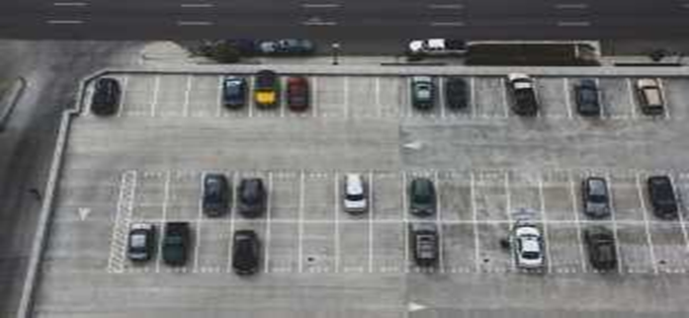

Figure 1: Parking Lot

While contemporary methods like image segmentation and Convolutional Neural Networks (CNNs) have been employed for identification parking area, challenges persist, especially in less-than-ideal conditions like low-light situations. Notably, the work of {Amato and Carrara (2020)} introduced innovative image segmentation and CNN techniques to detect open parking spaces.

Despite these efforts, there is a continued need for improvement in parking space detection. This research aims to discuss the challenges associated with exposure in various scenarios, contributing to enhanced parking management systems and urban transportation efficiency.

# Aim and Objectives

The principal aim is to suggest an intelligent parking system that utilizes the R-CNN technique to detect car number plates and various types of parking slots.

The subsequent research objectives that are formulated to align with the overarching goal are:

* + 1. Utilize R-CNN technique to distinguish between different types of parking slots.
    2. To create a model for available parking spaces that are available in the given area using the R-CNN technique.
    3. Evaluate the effectiveness of the proposed methodology and compare its performance against state-of-the-art techniques in the field.
    4. Enumerate the total number of cars within the parking lot.
    5. Implement a system to capture and identify vehicle occupancy within parking bays.

# Research Questions

1. How well does R-CNN based technique perform in identifying parking spaces for vehicles?
2. To what extent does the performance of the R-CNN technique in identifying parking spaces rely on the choice of features and parameters?
3. Which types of data—such as High-Resolution Images and Videos etc. perform better when using R-CNN technique to detect parking spaces?
4. How can machine learning algorithms be optimized to accurately classify and differentiate between different types of parking slots, considering factors such as orientation, size, and layout?
5. In the context of smart city infrastructure, what are the potential societal impacts and challenges associated with the widespread implementation of advanced parking space detection systems?
6. Can R-CNN technique be used to quickly identify and differentiate between different types of parking slots during emergency travelling to help drivers to get space easily with reducing fuel consumption.

# Scope of the Study

The research will encompass pre-processing procedures aimed at readying the data for clustering analysis, involving tasks such as data cleaning, normalization, and feature extraction. The implementation of R-CNN will be utilized to identify and differentiate vehicles from other objects within the parking areas, adapting to varying lighting conditions and weather conditions. The research will explore the use of different clustering configurations to optimize the overall effectiveness of the algorithm.

The study will employ standard evaluation metrics, including accuracy, sensitivity, specificity, and the F1 score, to assess the effectiveness of the proposed strategy (Yelpale et al., 2022). Additionally, there will be a comparative analysis of the strategy's performance against current state-of-the-art methods for detecting car number plates and distinguishing different types of slots for parking.

# 1.6 Significance of the Study

Locating area for your car parking in large metropolises can pose a significant challenge due to the increased private automobiles. The demand for parking has outstripped the available supply, creating an imbalance. Given the current scenario in major cities, there is a crucial need for the implementation of a parking management system capable of effectively monitoring parking spaces. This system should encompass essential features such as scalability, efficiency, reliability, and affordability to address the prevailing condition.

This approach improves citizen services by effectively managing and reducing on-street parking. Furthermore, it advocates enhance urban planning and decreased transportation congestion. Minimizes the effort exerted by drivers and saves time by facilitating secure parking in designated locations.

For improving safety by reducing traffic-related incidents associated with parking difficulties, promoting smoother traffic flow. Optimized parking systems lead to reduced traffic congestion and idling, ultimately contributing to lower emissions and a greener urban environment.

# Structure of the Study

This thesis is organized into 6 chapters, each focusing on different aspect of the research . Below is a brief outline of each chapter :-

Chapter 1 thesis addresses the challenges of urban population growth and traffic congestion, emphasizing the need for smart city solutions, especially in parking management . Section 1.2 explores the surroundings and problem declaration, highlighting the global increase in car ownership and insufficient parking infrastructure, proposing R-CNN-based intelligent parking systems as a solution. Section 1.3 outlines the aim of the research : to develop and evaluate this system, focusing on performance, optimization, and societal impacts. Section 1.4 details the study's methodology, including data preprocessing, R-CNN implementation, and evaluation metrics. Section 1.5 underscores the importance of effective parking management in reducing congestion, enhance safety, and promote environmental sustainability. Section 1.6 discusses the overall structure of the thesis, summarizing what is covered in each chapter.

Chapter 2 lays the groundwork for our study and addresses the issues raised in Chapter 1. Section 2.1 reviews the literature, discussing the challenges of finding parking spaces in cities and the advantages of using computer vision-based systems like ResNet50 and MobileNet over traditional sensors for better accuracy, even in bad weather and at night. Section 2.2 examines research on various advanced methods for real-time parking detection, comparing sensor networks, deep learning algorithms, and integrated systems, and noting improvements in accuracy and efficiency with technologies like magnetic sensors, Faster R-CNN, YOLOv3, and new deep learning techniques. Section 2.3 explores advancements in computer vision and image recognition, focusing on CNN and R-CNN techniques for detecting parking spaces. Section 2.4 identifies research gaps in both sensor-based and vision-based systems for parking detection. Section 2.5 describes the development process of our proposed solution, using YOLO and M-RCNN algorithms. Finally, Section 2.6 summarizes the chapter, highlighting our methodology, experimental setup, model performance analysis, and future implications.

Chapter 3 explains how we approached the research, focusing on the steps to collect and analyze images. In Section 3.1, we discuss creating a prototype using YOLO to detect parking spots automatically with publicly available datasets. Section 3.2 outlines our plan for collecting and analyzing data using YOLO and M-RCNN within the CRISP-DM framework. Section 3.3 emphasizes the importance of clearly marked parking spots for organized parking and effective model training. Section 3.4 highlights the need for accurate data on empty and occupied parking spots to train YOLO and M-RCNN effectively. Section 3.5 describes how we transformed raw data into standardized formats using the Pascal VOC dataset. Section 3.6 details training YOLO and Mask R-CNN with VOC images to find the best algorithm and generate classification weights. Section 3.7 evaluates the model's accuracy using real-time video streaming to test its object detection skills. Finally, Section 3.8 covers deploying the model on a Raspberry Pi for real-time parking spot classification, showing its practical use in managing parking spaces

Chapter 4 explains how we developed an advanced system to detect parking spots. In Section 4.1, we used Faster R-CNN with surveillance footage to find empty parking spaces, no extra sensors needed. Section 4.2 talks about choosing which features to focus on, like using the PKLot dataset, to classify parking spaces well. Section 4.3 checks how accurate our model is with real video footage. Section 4.4 trains YOLO and Mask R-CNN to spot parking spots accurately. Section 4.5 uses Python to classify parking spots in real-time from video. Section 4.6 tests how well our system finds empty and full parking spots. Section 4.7 summarizes how our work helps manage parking and traffic better with deep learning.

Chapter 6 concludes that we successfully made a model using YOLO and M-RCNN to find parking spots in real-time using the PKLOT dataset. Adding a motion-detecting feature made it better at checking uncertain spots, which is great for cities to save fuel and reduce traffic. Our study shows that using deep learning can accurately manage parking, achieving 92.6% accuracy. The prototype not only reduces traffic and time spent looking for parking but also helps businesses earn more by being clearer about parking availability. To improve, we should focus on better accuracy with lights for nighttime and instant alerts about parking.

# CHAPTER 2 LITERATURE SURVEY

* 1. **Introduction**

In the last ten years, there has been a substantial increase in private car ownership on a global scale. In spite of progress in technology, cities worldwide are grappling with insufficient infrastructure and parking availability, leading to heavy traffic, congested roads, pollution, and accidents. The scarcity of parking spaces is often overlooked, overshadowed by other urban challenges. Limited parking contributes to the ongoing issues of traffic congestion and environmental concerns. (Arnott & Inci, 2006a)

One of the major challenges nowadays drivers face is to find a parking spaces whether in urban areas or along roadways. This issue not only increases traffic congestion but also driver displeasure. Searching for an open parking space increases accidents as drivers divert their attention to navigate the parking search. Integrating parking bay recognition indicators would promptly reduce collisions, alleviate driver stress, and enhance driver satisfaction.

Contemporary communication and information engineering methodologies offer prospects for disseminating real-time parking space information, thereby enhancing accessibility for motorists. Additionally, fast rides or ride-division services have emerged as alternative transportation options, albeit with specific restrictions tied to accessibility.

The primary drawback of this configuration arises from prolonged processing times due to the CNN model's reliance on a constrained number of hidden layers and a dense distribution of neurons per layer. To address this issue, strategy proposes incorporating additional hidden layers.

However, an alternative approach under consideration involves using parking sensors instead of CNNs. It's important to note that parking sensors entail costly installation and maintenance expenses, which may present a downside compared to the CNN-based solution.(Szegedy et al., 2015) The rising demand for a computer vision-based system can be attributed to the substantial implementation expenses linked with alternative solutions like parking sensors.

Computer vision offers scalability, making it a more cost-effective and adaptable solution for addressing various needs and applications. Its ability to analyze visual data efficiently and accurately makes it an attractive option for tasks like object detection, recognition, and tracking, which are essential in diverse fields including transportation, surveillance, and automation. By leveraging computer vision technology, organizations can achieve scalability without incurring the prohibitive installation and maintenance expenses often associated with other sensing technologies like parking sensors. (De Almeida et al., 2015)

Our aim is to utilize transfer learning to detect vacant parking spaces without the need for sensors, particularly in challenging conditions such as nighttime and inclement weather. Previous studies by (Amato, G 2020) and Oresti (GI) overlook weather conditions, while (Lee CH 2013) and (Sastre RJ 2007) lack datasets containing dark night photographs, leading to decreased accuracy in nighttime parking spot detection. To address this, we employ a dataset captured continuously throughout the day to account for environmental variations. We implement ResNet50 and MobileNet, two widely-used convolutional neural networks, trained for this purpose.

As a result, this implementation can be applied in various scenarios, including:

* ResNet50 and MobileNet models offer a simple and effective approach, utilizing pre- trained architectures to improve accuracy. Unlike custom network designs, they allow for swift implementation and demonstrate superior performance in parking space detection systems.
* When it comes to accuracy and loss function, both models perform very similarly and show positive results in their analysis.
* Both the loss function and accuracy stabilize after around 100 epochs. Further training may lead to overfitting, which could pose problems for the model's performance.

# Related Research

Boda, V.K. & Nasipuri, Asis & Howitt, Ivan. (2007) proposed a real-time parking space locating system utilizing a network of wireless sensor nodes equipped with magnetic sensors. It discusses the strategies for designing a dependable detection method for vehicles based on magnetic signatures captured by these sensors. The design principles are established through analysis of empirical data gathered from a parking garage on a campus. Findings demonstrate that the proposed detection algorithm reliably identifies various passing vehicles with minimal error probability.(Hamada et al., 2015; Lee and Seo, 2016; Lee et al., 2016). Initially, a technique reliant on lines detects parking slot markings within the image, followed by clustering and fitting of these straight lines to create parking spaces utilizing geometric data from the slots. However, this line-oriented method is limited in its ability to distinguish between various types of parking slots, such as parallel, perpendicular, and angled spaces. The study examined a Vision-based Parking Slot Detection System utilizing a DCNN-based Approach and a Large-scale Benchmark Dataset. Authors identified uniform colors within slot markings. However, the system exhibited imperfections, notably under diverse lighting conditions. To enhance the parking slot detection accuracy, a series of line-based methods have been proposed. (L. Zhang et al. 2017)

* + 1. (Li and Zhao 2018) The integration of line and marking point detection for parking slots is employed to enhance detection accuracy. However, these methods predominantly depend on low-level visual features and might exhibit reduced robustness in challenging environmental conditions.
    2. (G. Khan et al. 2019) In the explored study on Deep-Learning Based Vehicle Count and Free Parking Slot Detection System, the author utilizes Faster R-CNN to detect parking spaces. Furthermore, the system determines vehicle entries and exits counts through deep convolution features. The proposed system is evaluated using the publicly available PKLot dataset, resulting in an improved accuracy of 8% compared to the baseline methodology.
    3. (D.Azshwanth, 2019) , The proposal involved utilizing convolutional neural networks in conjunction with an Adaboost classifier for detecting vacant and engaged parking spaces. However, the algorithm's computational time was excessively long, requiring 90 seconds to analyze a single image, making it impractical for large datasets. As a result, the author advocated for additional research in this field to devise a more efficient approach.
    4. (B. Sairam et al. 2020) discussed Automated Vehicle Parking Slot Detection System. In this study authors solve traffic problems using Deep Learning. The model receives all the first available parking slots in the area and real-time processing is performed on the data to determine if the slots are vacant or occupied by any vehicle and provides information about the empty slots. Besides finding a free parking spot for a vehicle, the model will also find an appropriate parking spot for 2 wheelers. The proposed system has improved robustness with a mask rate over 92.33 % and boundary recognition rate over 98.4 %.
    5. (C. Huang et al.2022) proposed solution for solution for automatic parking space detection using deep learning, addressing challenges posed by uneven lighting and complex backgrounds. A 360-degree panoramic system captures the vehicle environment, providing input for the detection system. A Faster R-CNN model is employed for detecting and extracting parking spaces, while background light removal and connected region-based extraction streamline the process. Experimental results demonstrate improved performance using 101-Floor ResNet compared to 50-Floor ResNet, achieving effective identification and accurate positioning of parking spaces.
    6. (G. Begum et al. 2023) proposed system addresses the need for efficient car parking detection using deep learning techniques. By utilizing images and videos captured from surveillance cameras, the system aims to determine the occupancy status of parking spaces, distinguishing between empty and occupied slots. Convolutional Neural Networks (CNN) are chosen as the primary algorithm due to their superior performance compared to traditional methods like Dijkstra and Ant colony algorithms. Additionally, the system employs the YOLOv3 object detection algorithm, leveraging its deep neural network architecture. These algorithms collectively enhance the accuracy of parking space availability detection, reducing the time drivers spend searching for vacant spots and minimizing frustration. The effectiveness of the car parking detection system is evaluated

using both images and videos, demonstrating its efficiency in accurately identifying parking spaces within a parking lot.

* + 1. Boda, V.K. & Nasipuri, Asis & Howitt, Ivan. (2007) proposed a real-time parking space locating system utilizing a network of wireless sensor nodes equipped with magnetic sensors. It discusses the strategies for designing a dependable detection method for vehicles based on magnetic signatures captured by these sensors. The design principles are established through analysis of empirical data gathered from a parking garage on a campus. Findings demonstrate that the proposed detection algorithm reliably identifies various passing vehicles with minimal error probability.
    2. Z. Xu, X. Tang, C. Ma and R. Zhang (2024), proposes an intelligent parking space detection algorithm leveraging image preprocessing and recognition techniques. Additionally, it introduces a CNN-LSTM based short-term demand prediction model, demonstrating superior accuracy in forecasting the availability of parking spaces.
    3. Karia.S, Temani.T and Gajara.V (2023),propose smart parking management system(SPMS) integrates Deep Learning and Machine Learning techniques to optimize parking space usage, mitigate traffic congestion, and address parking-related issues. By employing real-time number plate detection with Artificial Intelligence, it streamlines toll collection and management, enhancing efficiency and user experience. The paper discusses system architecture, implementation, and evaluation, highlighting potential benefits and future research directions.
    4. Haji Faraji, P. (2023). Propose an innovative method for accurately detecting and recognizing street parking signs, aimed at integration into vehicle systems. Through comprehensive evaluation, the YOLOv7-X model emerges as optimal, balancing accuracy and computational efficiency. Leveraging car camera footage from Vancouver, our approach achieves a mean Average Precision (mAP) of 97.4% for parking sign detection and 91% accuracy in identifying 43 different sign classes, demonstrating robustness and effectiveness.
    5. Truong, L. N. H., Clay, E., Mora, O. E., Cheng, W., Singh, M., & Jia, X. (2023). proposes an enhancement to Mask R-CNN, introducing Rotated Mask R-CNN to address its limitations. Evaluating its performance in vehicle instance detection within a parking lot

using unmanned aircraft system images, the study assesses various Rotated Mask R-CNN models. Results demonstrate high accuracy in real-time vehicle detection, with inference speed and total loss found to be closely linked to head networks and training schedules.

# Advancements in Computer Vision and Image Recognition

Computer vision enables machines to perceive, identify, and analyze images akin to human capabilities. This is made possible by the interdisciplinary field of computer science known as computer vision (CV), which operates within the realms of machine learning (ML) and artificial intelligence (AI). Using general learning algorithms and methods, CV aims to achieve a comprehensive understanding of visual data.

The following graphic depicts the relationship between Artificial Intelligence and Computer Vision: -

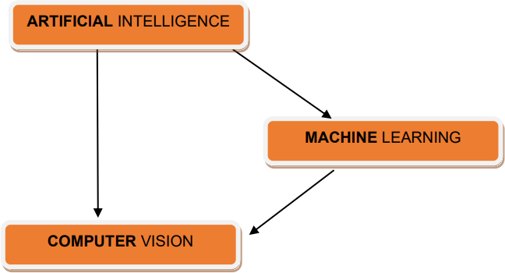

The intricacy of this research field may appear challenging for beginners, given the amalgamation of techniques borrowed from diverse engineering and computer science disciplines.

Computer vision's core objective is to interpret digital visual data (Zanella et al., 2014). Despite appearances, tasks are not necessarily straightforward because computers lack humans' innate visual perception capabilities. Unlike humans, computers do not inherently possess the ability to see and comprehend their environment.

# What is the functioning principle of computer vision algorithms?

Current technique in computer vision predominantly rely on pattern recognition, often employing convolutional neural networks (CNNs). Initially, a significant volume of visual data is utilized to train computers, involving the analysis of images and the labeling of each object. Through this process, computers identify patterns within objects.

For instance, if provided with a million photographs of cats, the computer evaluates the images to identify shared patterns among all cats, ultimately creating a model of a cat to represent the entire dataset. Consequently, the system can accurately determine whether a given image represents a cat each time new photographs are provided. (Lu et al., 2009)

# Image Recognition

Our cognitive systems facilitate sight, akin to the adage "What you perceive is what you receive." Creatures effortlessly discern between a dog, a cat, and a flying saucer. This ability stems from the intricate wiring of the human mind to interpret visuals, a process challenging for computers to replicate. Optical Character Recognition (OCR) is a prevalent technique for image recognition. A scanner has the capability to recognize text within an image and transform it into a text document. OCR is frequently utilized for extracting text from images containing registration numbers. Teaching a computer to recognize different images involves a process similar to machine learning modeling.

Here's an outline of the steps for building an image identification technique.

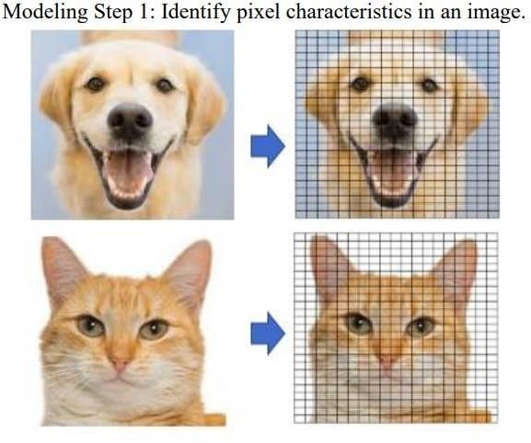

Figure 1: Model Step 1- Pixel Characteristic Image

Initially, various characteristics are extracted from the image. Figure (1) illustrates the "picture element" responsible for constructing an image. The range of numbers used to describe each pixel, known as color depth, determines the intensity of colors available in an image. For instance, a black & white image assigns a single value between 0 and 255 to each pixel. RGB images combine red, green, and blue components, each ranging from 0 to 255, enabling the creation of any color. Additionally, an image's dimensions are defined by its pixel count, with a 1024x768 image consisting of 1,024 columns and 768 rows. (Lu et al., 2009)

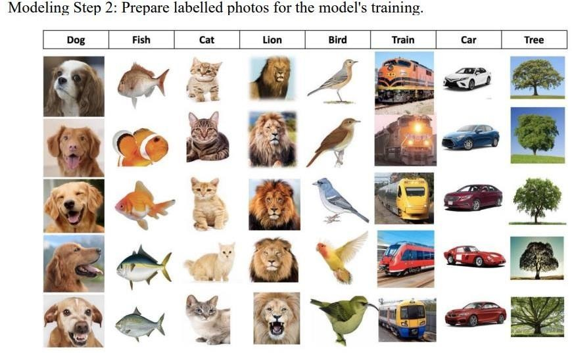

Figure 2: Model Step 2 - Collection of Labeled Photos for Model’s Training

* By dissecting each image into hundreds of characteristics and utilizing recognized descriptions, we can guide a model. Figure (2) displays a collection of labeled photos, such as "dog" or "fish." With additional examples for each classification, a technique can be trained to distinguish between photos of dogs and fish more accurately. In this scenario, we can utilize previously assigned classifications to train the model. This approach is referred to as "supervised machine learning.

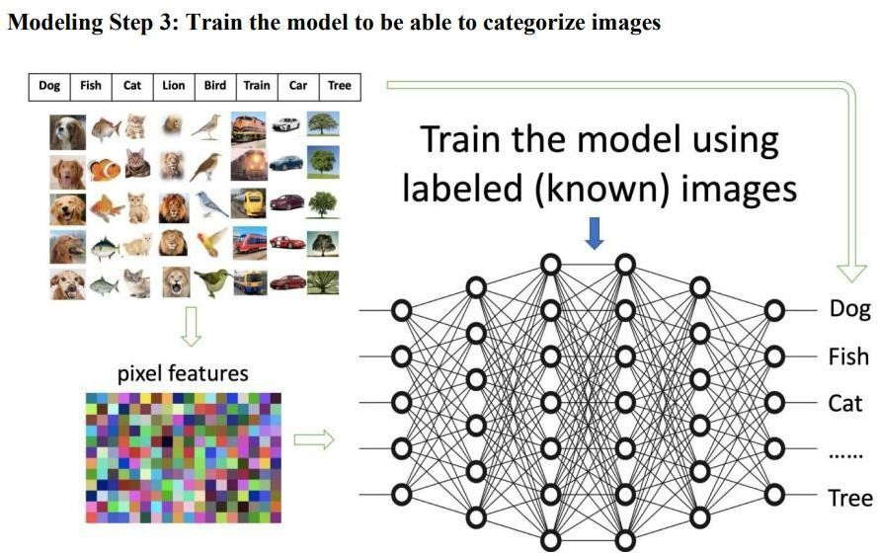

Figure 3: Model Step 3 – Train Model using Labelled Images

* Figure (3) illustrates the process of training a model using pre-labeled images. The intermediate connections can be likened to a vast network. Labels are provided on the output side, while the input side receives the extracted versions of the photographs. In this setup, the objective is to train the networks to correctly identify the label in a photograph based on its input characteristics.

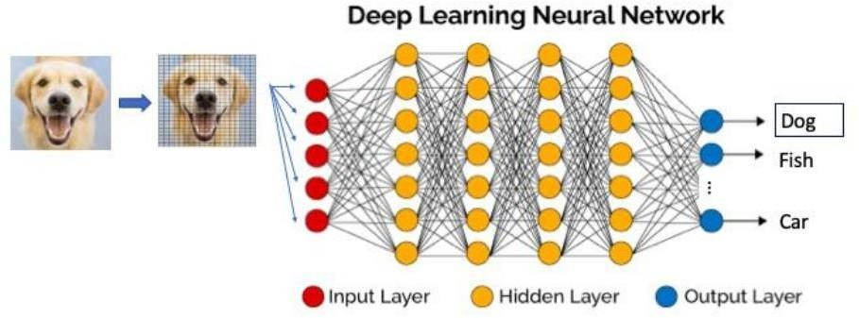

Figure 4: Model Step 4 – Figure Deep Learning Neutral Network

* Modelling Step 4: To classify or predict a new image into one of the classes, a trained technique can be employed. Figure (4) demonstrates the recognition of a recent image as a dog image. It's crucial to emphasize that the resulting image will also incorporate the pixel features extracted from the original image during this procedure.

# Convolutional Neural Network Techniques

Convolutional Neural Networks (CNNs) are a type of deep learning networks specifically designed for processing images. CNNs allocate varying weights to elements within images to discern them from one another. Through adequate training, CNNs have the capability to autonomously acquire recognition and differentiation skills across diverse images. These networks are structured with layers of neurons, each transmitting information sequentially to the subsequent layer.

During training, the network is presented with a large dataset of images to learn from, allowing it to accurately categorize them. If the network makes incorrect predictions, supervised learning techniques are applied to adjust the weights of the neurons, improving future predictions.

Through this process, CNNs can extract unique features from images and classify them accurately. The visualization below depicts the architecture of a CNN.

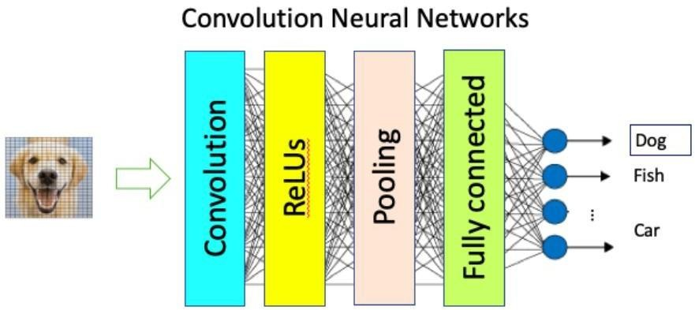

Figure 5: Convolutional Neural Networks

# Region Based CNN (R-CNN)

The enhanced CNN algorithm discussed by Malik (2016) focuses on region selection within images, aiming to classify specific areas rather than the entire image. This approach involves identifying regions of interest within an image and conducting classification solely on those regions. By narrowing the scope of analysis to selected areas, the algorithm optimize

computational resources and enhances efficiency in image classification tasks. This method

emphasizes targeted analysis, enabling more precise identification and classification of relevant features within images.

Malik's algorithm represents an advancement in CNN techniques, demonstrating a refined approach to image analysis and classification.

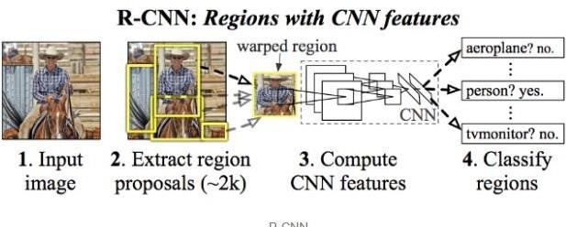

Figure 6: Region Based CNN

# Faster R-CNN

Fast Region-based Convolutional Neural Network (Fast R-CNN) represents a significant advancement over RCNN, addressing its computational inefficiencies and offering enhanced image processing speed. The key mechanism involves passing an image frame through a convolutional neural network (CNN) to generate a convolutional feature map, capturing essential visual information. From this feature map, regions of interest are identified and encapsulated into squares. These areas are subjected to classification utilizing a SoftMax layer, which determines the class of each designated region. This streamlined approach results in improved processing time compared to RCNN, where each proposed region is evaluated individually.

Malik (2016) highlights the importance of Fast R-CNN in accelerating object detection tasks, making it a compelling choice for various computer vision applications. By leveraging Fast R- CNN's advancements, researchers and practitioners can enhance the efficiency and effectiveness of image analysis and object detection systems

In the R-CNN algorithm the enhanced processing efficiency is due to performing only one calculation per image, leading to the creation of a feature map. This differs from approach in R- CNN, where the neural network is fed with 2000 proposal regions for each iteration.

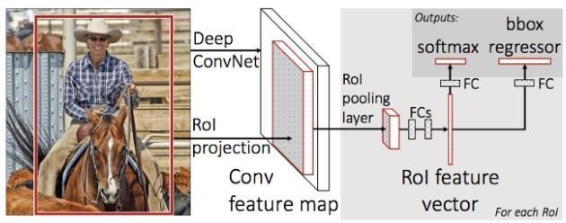

Figure 7: Faster R-CNN

# Mask RCNN

(Rahul K. Kher, 2017) Mask R-CNN is an advanced deep learning approach renowned for its prowess in object detection, achieved by meticulously segmenting items within images or video streams. It adeptly detects and delineates bounding boxes, masks, and the categorical identities of objects within a given frame. Initially, the algorithm strategically proposes regions where objects are likely to be found, laying the groundwork for subsequent analysis.

As the process progresses, precise predictions of each object's class are made, alongside the refinement of bounding boxes and the creation of detailed pixel-level masks, ensuring unparalleled accuracy in object localization and segmentation. These sophisticated techniques grant the algorithm remarkable versatility, enhancing its performance across a wide array of computer vision tasks, spanning from object recognition to comprehensive scene understanding.

# YOLO

The YOLO (You Only Look Once) technique, a pioneering method in object detection, offers a novel approach for swiftly and precisely identifying objects within images. By leveraging a single convolutional neural network (CNN), YOLO efficiently determines bounding boxes and

associated object classes in real-time. This streamlined methodology enhances the speed and accuracy of object detection, rendering it an appealing option for a myriad of computer vision applications. As the cornerstone of modern computer vision research, YOLO holds significant potential for advancing the capabilities of autonomous systems, surveillance technology, and image analysis in diverse fields.

Therefore, its comprehensive understanding and application are paramount for researchers and practitioners in the realm of computer vision and artificial intelligence. (Malik, 2016).

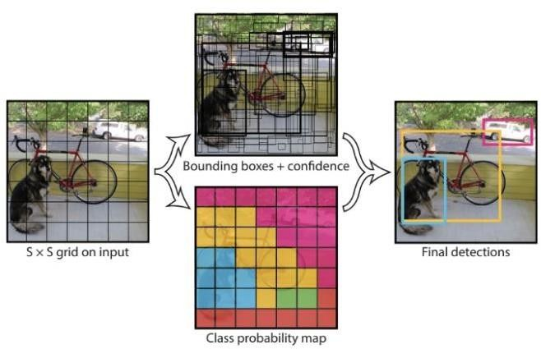

Figure 8: YOLO Algorithm

The algorithm functions by segmenting an image into a grid of size S*S, wherein every grid is examined for potential bounding boxes. Each bounding box is then evaluated by the network, receiving a classification and an offset probability. Bounding boxes exceeding a predefined

threshold for classification probability are identified and utilized to detect objects within the image (Malik, 2016).

# Neural Networks

In a neural network, neurons are interconnected, facilitating the transmission of information from one neuron to the next. Each neuron performs computations on the received information before transmitting it to subsequent neurons in the network. In computing, this process involves assigning weights to each neuron, which are then adjusted during training to optimize network performance.

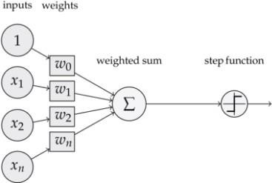

Figure 9: Perceptron Neural Network

# Research Gap

Previous research has elucidated various aspects of sensor-based technologies and vision- based systems for vehicle detection in parking areas. Sensor-based technologies, including wireless sensor networks and wireless magnetic sensors, exhibit high accuracy and demand minimal computing resources for operation. However, their applicability is often constrained to parking

slots in restricted areas due to installation complexities and high costs (Rivano & Mouël, 2017). Studies on vision-based systems suggest their effectiveness in efficiently locating vehicles in large parking areas, accommodating both open and enclosed spaces. Nonetheless, these systems are vulnerable to changes in lighting conditions when models are not properly trained. They operate on predetermined guidelines rather than adaptive intelligence and require significant computational resources for both training and execution. This research endeavors to improve the precision of car and parking space detection in a more resilient manner, impervious to environmental variations.

It employs the YOLO and M-RCNN algorithms for object detection and integrates a classifier to predict parking spot occupancy, aiming for improved efficiency.

# Process Model

The diagram below depicts the proposed process model outlining the evolution of the solution.

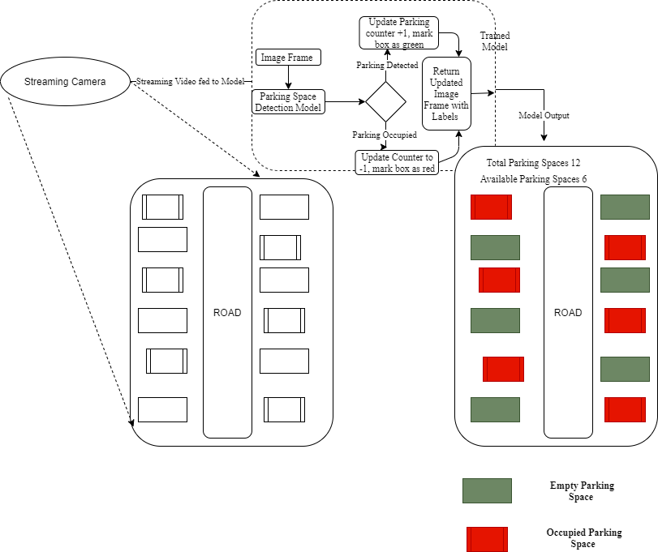

Figure 10: Process Model for Automated Parking Spot Detection

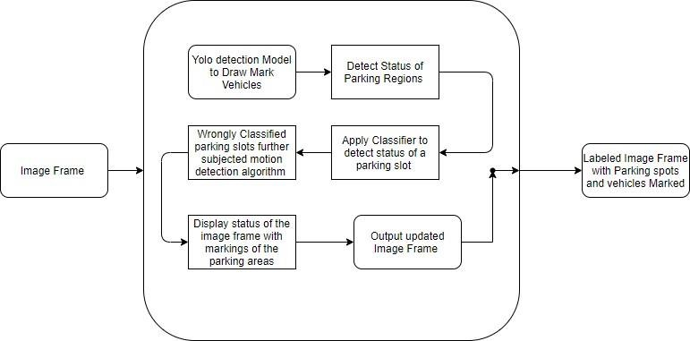

Figure 11: Model Classification Process

# Summary

In the forthcoming sections, we begin with a review of previous studies in driveway detection. Methodology and experimentation setup detail both model training/testing and data preprocessing. Results analyze model performance, particularly its ability to predict empty parking spaces. An analysis comparing algorithms with the most recent model is performed on identical datasets. Ultimately, considerations for future implications and decisions are discussed, thereby concluding our inquiry.

# Introduction

**CHAPTER 3**

# RESEARCH METHODOLOGY

The primary aim of the research project is to create a prototype that employs computer vision techniques for the automated detection of parking spots within parking areas. To achieve this goal, publicly available data, possibly from (Giuseppe Amato, 2015), was utilized for training and testing purposes. This dataset likely contains images or videos of parking areas with annotated parking spots indicating whether they are vacant or occupied. For the detection of objects within the parking areas, the YOLO (You Only Look Once) algorithm was selected. YOLO is renowned for its real-time object detection capabilities and is frequently employed in computer vision applications.

In this context, YOLO was employed to identify objects, primarily cars, within the parking area images or videos. Moreover, a classifier was incorporated into the system to assist in categorizing parking spaces as either empty or occupied, depending on the presence or absence of vehicles within them. This classifier likely utilizes machine learning techniques to make these determinations. Following the development of the model, it underwent training and testing phases using the collected dataset. This involved adjusting model parameters and fine-tuning its architecture to ensure accurate detection and classification of parking spots. Subsequently, the trained model was evaluated using various parking area videos or images to assess its performance in predicting and identifying vacant and occupied parking areas.

Evaluation metrics such as accuracy, precision, recall, and F1 score were likely employed to quantify the model's performance. Overall, the research endeavors to provide a practical solution for automating parking spot detection, which could find applications in diverse domains such as smart parking systems, traffic management, and urban planning. The iterative refinement of the model based on evaluation results suggests a commitment to optimizing its accuracy and efficiency for real-world deployment.

# Research Design

(Uma Sekaran, 2016) describes search design strategically plans data collection and analysis, specifying variables and methodologies to address research inquiries. It ensures robust data acquisition through defined methods like surveys or experiments, followed by meticulous analysis employing statistical, qualitative, or computational approaches.

Ultimately, the structured framework guides the research process, enabling the generation of meaningful conclusions and contributions to the field.

The project employed YOLO and M-RCNN algorithms to detect vehicles and delineate parking spaces in parking areas. The status of each area was determined by classifying objects as vehicles or other items, establishing the area's occupancy. Throughout the prototype development lifecycle, the CRISP-DM methodology was followed, comprising phases like business understanding, data understanding, data preparation, modeling, evaluation, and deployment. This structured approach ensured systematic progress from understanding the problem domain to deploying the developed solution effectively.

# Business Understanding

A parking spot refers to a designated area reserved for parking vehicles. These areas are established to facilitate organized parking and prevent obstruction of other activities by parked vehicles in urban or other settings. To optimize parking space management, most spots are clearly marked to indicate where drivers should park their vehicles and discourage double parking. Consequently, well-marked parking spots facilitate efficient vehicle parking, ultimately increasing the parking capacity of an area. Additionally, properly labeled parking spots simplify the process of training a model to determine their occupancy status. In our research, the clear labeling of parking spots ensures accurate delineation during the training of our classification model.

# Data Understanding

The presence of two critical data types—occupied parking spot counts and the count of empty slots—is essential for automated identification of parking space status in this project. To handle the extensive data necessary for accurate model training, the researcher chose to train both YOLO and M-RCNN algorithms for vehicle object detection. Subsequently, the most effective algorithm was selected to create a prototype capable of classifying parking areas as either vacant

or occupied. This approach guarantees the development of a robust solution for automated parking space status identification, utilizing advanced object detection algorithms to improve accuracy and efficiency.

# Data Collection and Preparation

During this phase, the focus was on transforming raw data into standardized formats to facilitate model training. Screenshots of parking areas were captured to mark parking slots for classifying areas as occupied or not. The Windows snipping tool was utilized for this purpose, ensuring efficient capture of parking area visuals from videos.

Training images of vehicles were obtained from the Pascal VOC dataset (Pascal2, 2014), which offers a comprehensive collection of images suitable for training vehicle detection models. This dataset provides standardized image class data, commonly used for image classification tasks. The researcher identified it as an ideal data source due to its provision of testing, training, and validation data sets, ensuring robust model training and evaluation processes.

# Modelling

Using VOC images, YOLO and Mask RCNN algorithms were trained for object detection, with 25,494 images allocated for training and 10,926 for testing model accuracy. Following successful training, metrics including training time and object classification accuracy were recorded to assess algorithm efficiency. The most effective algorithm was identified based on these parameters. Subsequently, weights were generated for the optimal model, facilitating vehicle and parking space classification in the parking space detection prototype, ensuring accurate real-world application.

The development process included the creation of a flow chart outlining object detection using the efficient algorithm, guiding the implementation of the prototype. Additionally, a dedicated program was developed to aid in marking parking areas, streamlining the process of annotating parking spots in the captured parking photos. This program offered a user-friendly interface, simplifying the task of identifying and labeling parking spaces, thereby enhancing the efficiency and accuracy of the overall project workflow.

# Evaluation

The model was assessed through real-time video streaming of the parking area, gauging its precision in classifying parking spots as vehicles entered and exited. Moreover, its proficiency in accurately detecting objects within the parking zone was scrutinized.

The evaluation extended to analyzing how well the model's performance aligned with the project's objectives, seeking areas for potential enhancement in future iterations. This thorough evaluation aimed to verify the model's efficacy in achieving the project's aims and to offer valuable insights for optimizing and advancing its functionality in future development cycles.

# Deployment

The model was deployed on a Raspberry Pi, where it processed streaming video images of the parking area. Through this setup, the model effectively classified parking spaces as either vacant or occupied in real-time. The results of this classification were then displayed, providing users with up-to-date information on parking space availability. This deployment demonstrated the practical application of the model in a real-world scenario, facilitating efficient parking space management and enhancing user experience.

# Introduction

**CHAPTER 4**

# ANALYSIS, DESIGN, AND IMPLEMENTATION

We delve into the multifaceted domain of driving knowledge, covering its development, educational aspects, and deployment in testing scenarios. Our primary focus centers on advanced parking techniques designed to accurately discern empty parking spots and monitor the arrivals and departures of vehicles. These techniques hold immense potential for enhancing traffic management strategies and yielding considerable energy savings.

A key innovation lies in our utilization of image streaming from surveillance footage, a method that obviates the need for additional sensors within the parking area. Through this approach, we achieve effective detection of parking spaces with a high degree of reliability.

Our paper introduces a groundbreaking methodology grounded in Faster R-CNN, a sophisticated deep learning model, for vehicle detection. This model enables us to precisely identify parking vacancies, significantly improving the efficiency of parking space utilization. Furthermore, we harness deep convolutional features to estimate the flow of vehicle entrances and exits, offering a comprehensive solution for optimizing parking space management and traffic flow.

By delving into these advanced parking techniques, we aim to provide a deeper understanding of their potential impact on traffic optimization and energy conservation, ultimately contributing to smarter and more sustainable urban environments.

# Attribute Selection

The model underwent training using a combination of both automotive and non-automotive items in the study. This was done to ensure that the technique is adequately instructed to discern various occurrences within a parking lot and accurately differentiate between vehicles and other

objects. Throughout the model's training process, images featuring diverse settings with multiple vehicles were utilized. The four coordinates corresponding to each parking slot were selected as attributes for defining the parking area. When a video stream image was inputted into the model, it successfully tracked the number of vacant and occupied parking spaces, utilizing the parking slot coordinates to determine the precise location of each parking spot.

For deep learning-based systems focusing on tracking and identification, it is imperative to have a substantial number of training instances for each vehicle type. The diversity of the dataset significantly influences the effectiveness of the system. To effectively identify parking vacancies and track vehicles from various perspectives, particularly from elevated viewpoints, robust identification capabilities are essential.

Deep learning-based parking management systems often rely on publicly available datasets such as the PKLot (Parking Lot) dataset to locate vacant parking spaces. I utilized the PKLot dataset in my research. This dataset is widely used in the field as it contains a diverse range of images captured from various angles, making it a reliable resource for training deep learning models. The PKLot dataset provides ample examples for training models to accurately detect empty parking spaces, contributing to the effectiveness and reliability of parking management systems based on deep learning techniques. (De Almeida et al., 2015)

PKLot dataset holds significant merit due to several compelling reasons :-

* + - Diverse Image Collection: The PKLot dataset offers a diverse collection of images captured from various perspectives and under different environmental conditions. This diversity ensures that the trained model can effectively generalize to real-world parking scenarios, enhancing its reliability in practical applications.
    - Public Availability: Being publicly available, the PKLot dataset facilitates transparency and reproducibility in research. Other researchers can access and utilize the same dataset for benchmarking and comparison purposes, fostering collaboration and advancing the field collectively.
    - Annotated Parking Spaces: The PKLot dataset typically includes annotations for parking spaces, indicating their occupancy status (occupied or vacant). This annotated information

serves as ground truth data for training and evaluating parking space detection algorithms, enabling the development of accurate and robust models.

* + - The PKLot dataset dataset comprises over 12,000 images and more than 160,000 annotated parking spaces. This substantial dataset size significantly enhances the accuracy and dependability of deep learning model training.
    - Community Validation: As a well-established dataset within the research community, the PKLot dataset has undergone scrutiny and validation by multiple researchers. Its widespread usage and positive reception indicate its reliability and suitability for training deep learning models for parking space detection tasks.
    - The PKLot dataset has established itself as a standard benchmark in the field, enabling the comparison of different deep learning-based methods for parking spot detection. Its widespread adoption simplifies the evaluation of model efficiency, aiding in the identification of the most effective strategies. PKLot has gained popularity as a preferred choice for locating open parking spaces in deep learning applications due to its provision of real-life annotated data, a large dataset, and a standardized benchmark for assessing model performance.

# Analysis of Testing Data

In the investigation of the VOC dataset, a mixture of vehicle and non-vehicle images was utilized. The trained model was then tested on this dataset to evaluate its performance in distinguishing between vehicles and other objects. Specifically, one set of images containing assured vehicle photos was used for training, while another set comprising various images was used for testing. It's worth noting that the test results were evaluated under the same conditions as the training data, with consistent visual size and the number of images per instance.

To assess the accuracy of the model, a continuous stream of video footage depicting cars entering and exiting a parking lot was employed. This footage captured various parking lot scenarios, including cars entering, exiting, and parking within the lot. Each time a vehicle entered or exited the parking area, the number of vacant and occupied parking spaces was manually recorded. These values were then compared with the predictions provided by the model.

Through this process, the model's performance in accurately identifying parking lot conditions, including the number of available and occupied parking spaces, was evaluated based on real-world video footage.

# Modeling

The YOLO and Mask R-CNN algorithms underwent training using the VOC dataset, which includes images containing cars as well as other objects. During training, the models were provided with images featuring cars along with corresponding coordinates indicating the location of these vehicles within the images. This information was stored within the deep network of the algorithms, enabling them to classify vehicles accurately when presented with new images.

Following the successful completion of the training process, the next step involved testing the accuracy of the algorithms to determine the most suitable one for the parking spot detection prototype. During the testing phase, both algorithms were evaluated using testing data sourced from the VOC dataset. This testing data comprised images similar to those used during training, thereby enabling a comprehensive assessment of the algorithms' performance in accurately identifying parking spots.

In the subsequent phase, parking spot labeling was conducted, which entailed capturing coordinates for all parking areas and saving them in a file. This process is crucial for training the model to accurately detect both vacant and occupied parking spaces. To achieve this, an image of the parking area was captured specifically for training the classifier. This image serves as the basis for teaching the model to recognize and distinguish between occupied and vacant parking spots. The coordinates of each parking area within the image are annotated and stored in a file, providing the necessary ground truth data for training the classifier effectively.

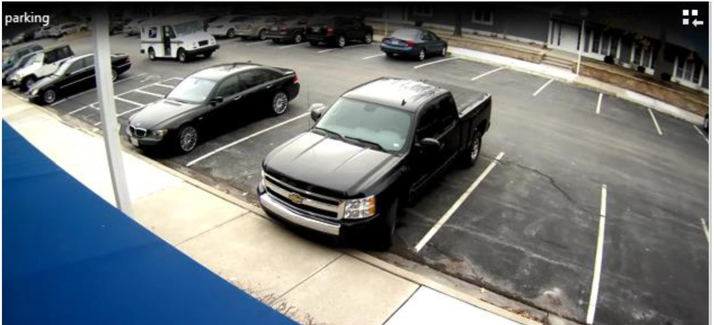

Figure 12: Image of the Parking Area

To streamline the process of marking parking spots efficiently, we developed a small Python program. This program reads an image and provides a user-friendly interface for marking parking polygon areas. The user can simply double-click on the desired coordinates within the image to define the boundaries of the parking areas.

The Python program utilizes libraries such as OpenCV to handle image processing tasks and GUI (Graphical User Interface) frameworks like Tkinter to create the interactive interface. By incorporating this program into our workflow, we ensure automated and faster marking of parking spots, reducing the manual effort required for this task.

This approach not only enhances efficiency but also enables accurate annotation of parking areas, which is essential for training the parking spot detection model effectively. With the user-friendly interface provided by the Python program, annotating parking spots becomes a straightforward and intuitive process.

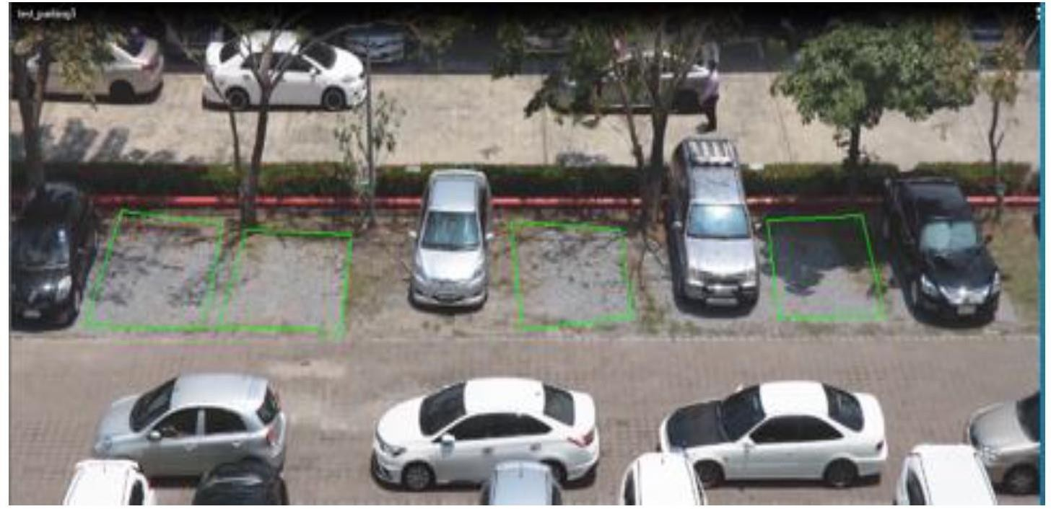

Figure 13: Parking Areas Marked

The marked parking areas in the image serve as reference points for the model to track occupancy. Coordinates are saved in YAML format after four double clicks, starting from the first clicked slot. **PyYAML** facilitates parsing within Python scripts, ensuring human and computer readability. This method streamlines the annotation process and enables efficient monitoring of parking space status. After successfully marking the parking spaces, the coordinates were stored in a YAML file to contain information about the parking areas. An example excerpt of the parking coordinates is presented below.

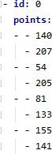

Figure 14: Parking Slot Coordinates

The parking coordinates were represented in terms of their x and y axis locations, where each point was denoted by a pair of values. The x coordinates were indicated by the first value and the y coordinates by the second value. The "id" element served as the parking location identifier, which also acted as the parking counter within the model. Structured representation streamlined parking data storage and retrieval for model.

**Model Flow Chart**

The flow chart illustrating the testing and training of the model was utilized for the process.

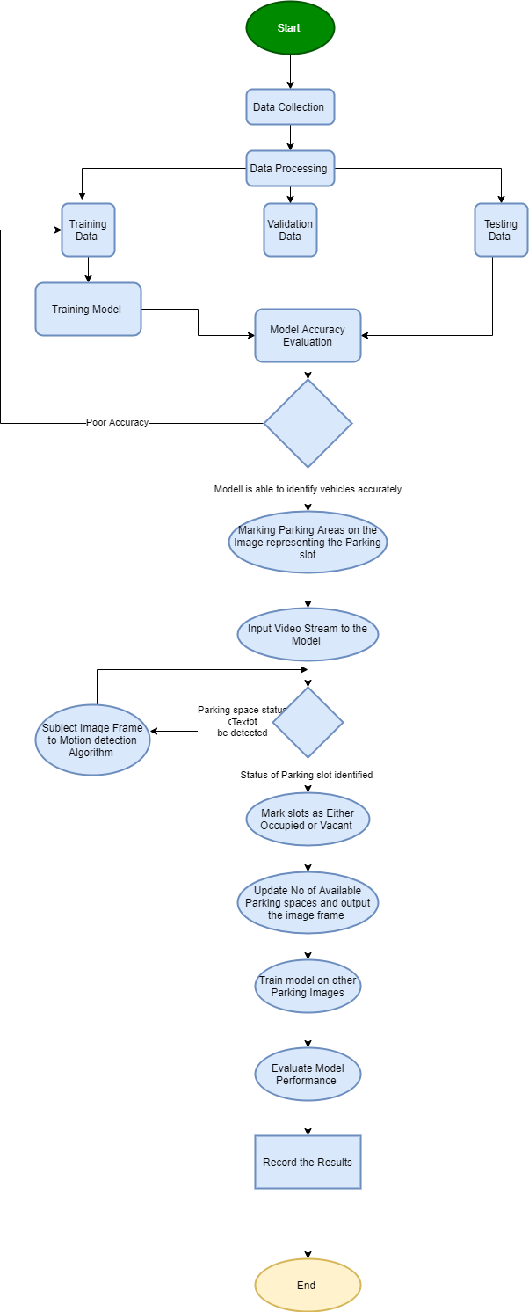

Figure 15: Model Flow Chart

# Implementation

Implemented using Python, the model processes real-time video streams captured from parking areas. It employs classification algorithms to determine whether parking slots are vacant or occupied, providing instantaneous feedback on the status of each slot. Additionally, the model dynamically updates the count of available parking areas, ensuring accuracy even as spots become occupied or vehicles depart. This real-time tracking and classification system offers efficient management of parking resources, aiding in optimal utilization and convenience for users.

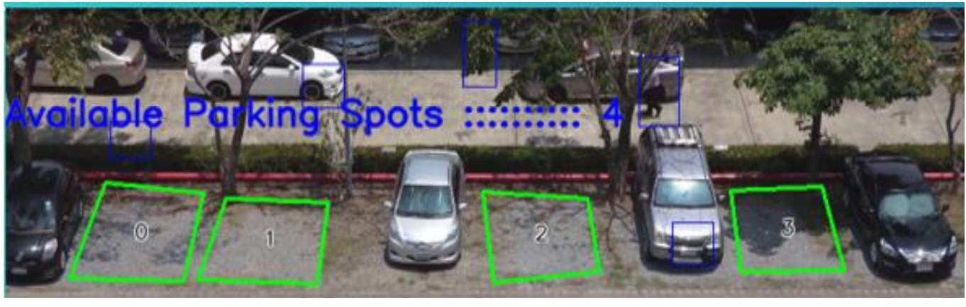

Figure 16: Video Stream of the Parking Area

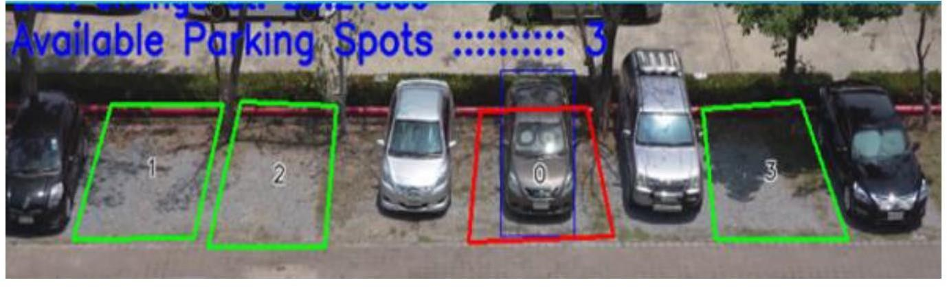

Figure 17: If video stream output of detected parking spots, vacant spots and parking count

# Prototype Evaluation

The prototype underwent evaluation against the predetermined objectives outlined in the research introduction. Assessment primarily focused on its accuracy in distinguishing between vacant and occupied parking slots within a parking area.

This evaluation involved supplying the model with streaming parking slot data, simulating real- world scenarios of cars entering and exiting the parking area.

# Summary

The development of an intelligent parking infrastructure offers promising prospects for reducing fuel consumption and optimizing traffic management by accurately tracking vehicle entries and exits while effectively identifying unoccupied parking spots. Leveraging optical streaming from cameras eliminates the need for additional sensors within the parking area.

In this study, a novel Faster R-CNN-based method for vehicle detection was developed to identify parking spaces. Deep segmentation features were utilized to estimate the number of vehicle entries and exits. Through evaluation using the publicly accessible PKLOT dataset, the proposed methodology demonstrated an 8% increase in precision compared to previous approaches.

This advancement underscores the potential of utilizing deep learning techniques for enhancing parking space management and traffic optimization, with tangible benefits in fuel efficiency and overall traffic flow.

# CHAPTER 5 RESULTS AND DISCUSSION

* 1. **Introduction**

In this chapter, we examine how the model performs under different test conditions. We assess at how fast it can detect parking spots. It majorly focuses on 3 key metrics: Accuracy of detection, Speed of identification and the edge detection approach is a key component in image processing, especially in tasks require distinguishing between occupied and vacant parking spots.

# Model Performance

* + 1. **Object Detection and Classification Using YOLO Algorithm**

The YOLO algorithm is a tool for recognizing objects, like cars, in pictures and videos. When it was used in a parking area, here's what happened: On average, the algorithm correctly spotted cars 82% of the time. But it wasn't always consistent—sometimes it only got it right half the time, and at its best, it found 88% of the cars. This means the YOLO algorithm did a pretty good job.

Detection rates varied, with the lowest being 50% and the highest reaching 88%.

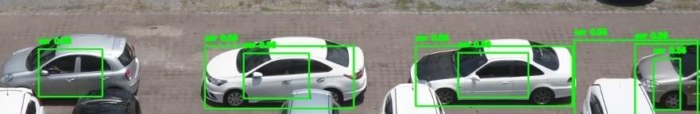

Figure 18: YOLO Car Detection

YOLO Performance in Car Detection Scenarios in the below result:

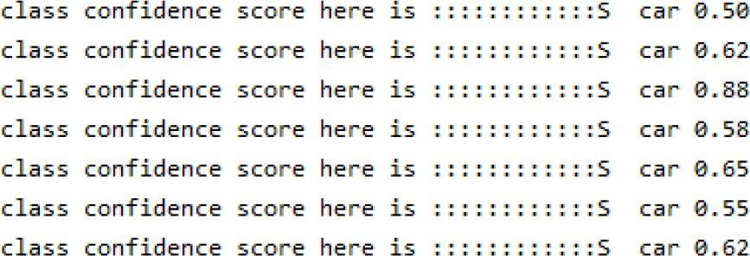

Figure 19: YOLO Performance in Object detection

# Mask R-CNN in identifying and categorizing objects

The Mask RCNN algorithm is another system that achieved 100% accuracy in detecting cars in a video stream, with a lowest detection rate of 94%. However, it took longer to detect vehicle objects compared to the YOLO algorithm. Consequently, it was deemed unsuitable for use in the prototype setup.

Based on the results, YOLO tool was tested for object detection in our automated car parking prototype. The model successfully detected vehicles and their status in five video streams from different parking lots, including vehicles entering and leaving. Two tests were conducted: one with motion detection enabled and another with it disabled.

The following outcomes were achieved upon enabling motion detection:

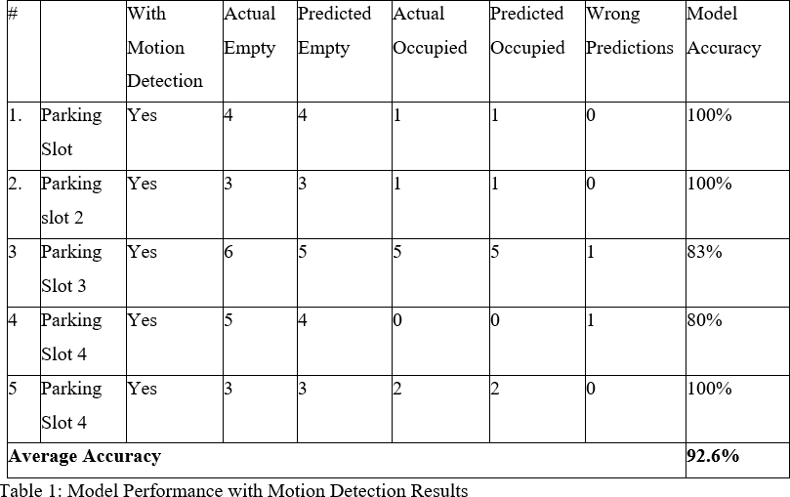

The following table represents a summary of the findings obtained under conditions where motion detection was turned off:

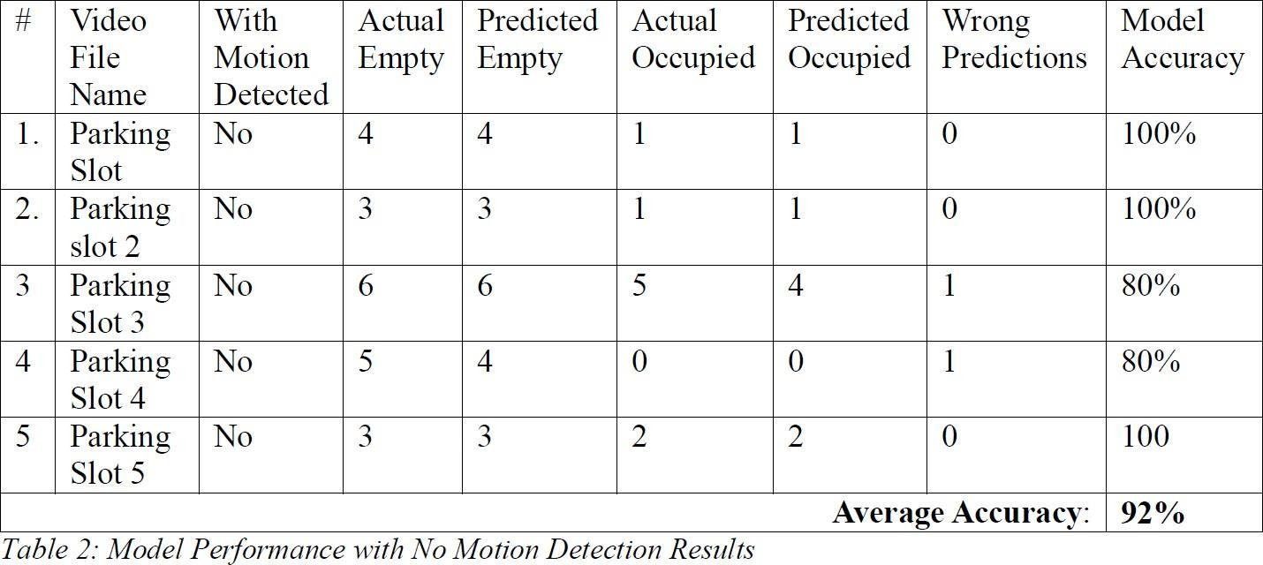

# Discussions

In conclusion, by combining of YOLO and Mask R-CNN algorithms detecting and categorizing car parts within video streams. However, there are notable differences in both speed and accuracy when detecting vehicles and objects. YOLO outperforms Mask R-CNN in terms of speed, particularly in distinguishing cars from other objects in video data.

While Mask R-CNN achieves high precision in identifying car components, it requires significantly more processing power and time compared to YOLO. The extensive processing demands of the Mask R-CNN method may not be the optimal choice for our research due to its high computational demands.

The following image displays the detection outcomes attained with the M-RCNN model.

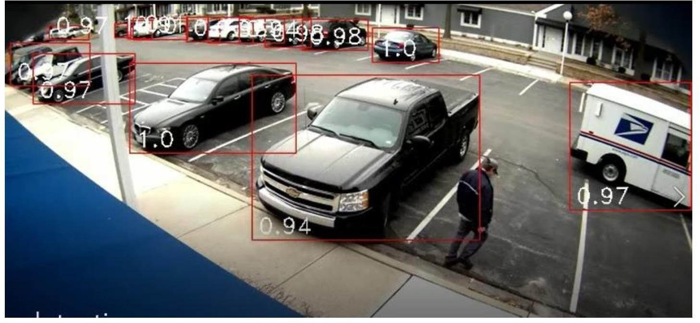

Figure 20: Mark- RCNN Vehicle Detection

Here is an illustration of the identical image found using the YOLO method.

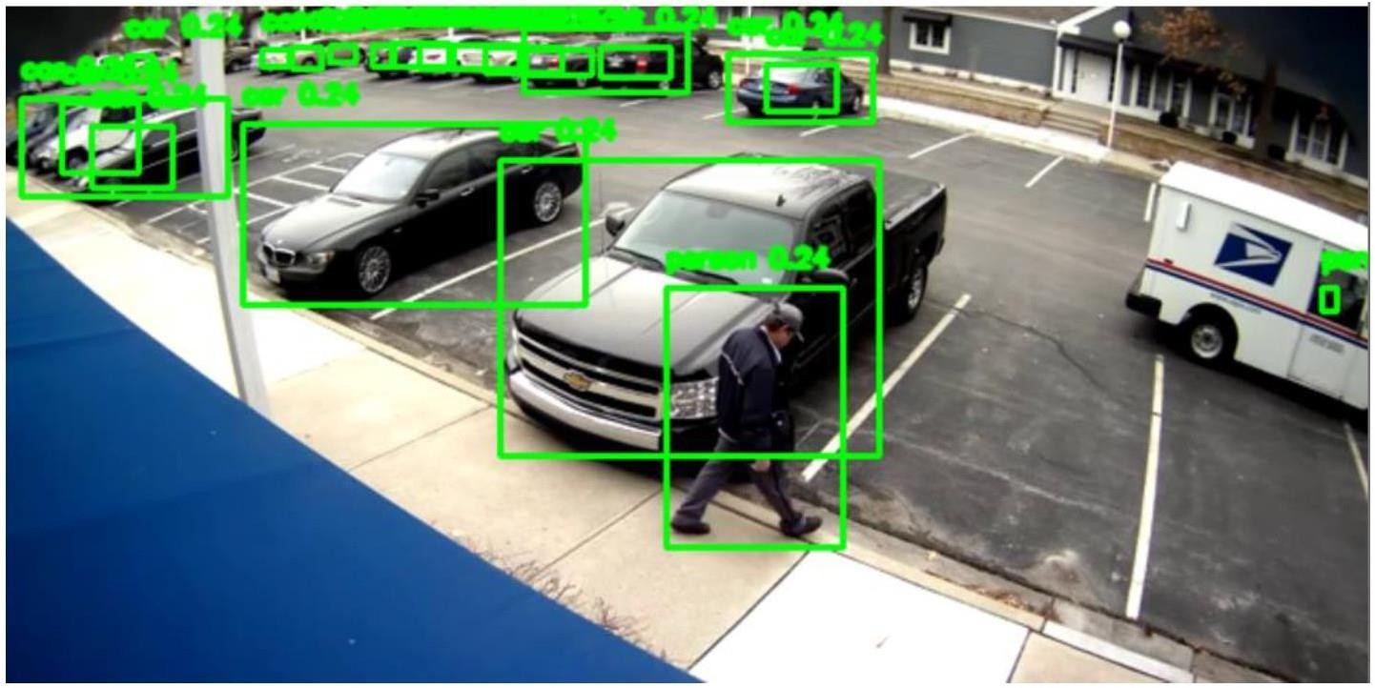

Figure 21: Yolo Image Detection

Comparing Mask RCNN with YOLO, Mask RCNN is better at finding vehicles but needs more resources than YOLO, according to what's been shown. This means M-RCNN utilized larger datasets for prediction than YOLO.

The research examined two techniques for detecting boundaries: Laplacian and Sobel identification matrices. Sobel detects edges by analyzing each frame's initial outcomes along the X and Y axes separately. It employs a complex 3-kernel operation with the original image to establish equations for both axes.

Below, we can see the image's results following the application of the Sobel edge detection matrix.

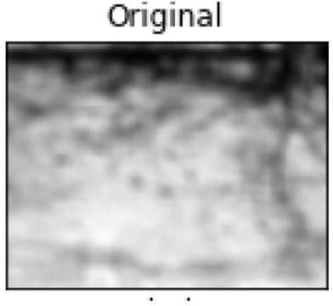

Figure 22: Original Image of the Parking Spot

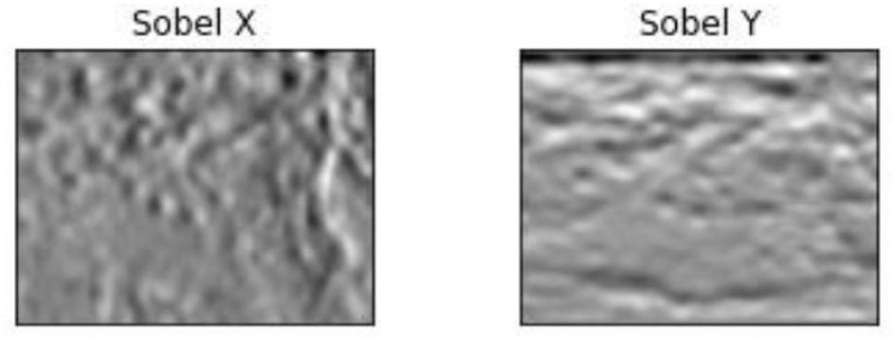

Figure 23: Sobel Edge Detection Technique

Below are the results obtained from utilizing the Laplacian edge detection method, which employs a singular matrix to process second-order derivatives simultaneously.

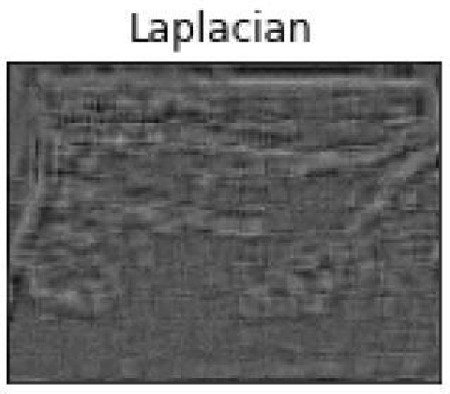

Figure 24: Laplacian Edge Detection

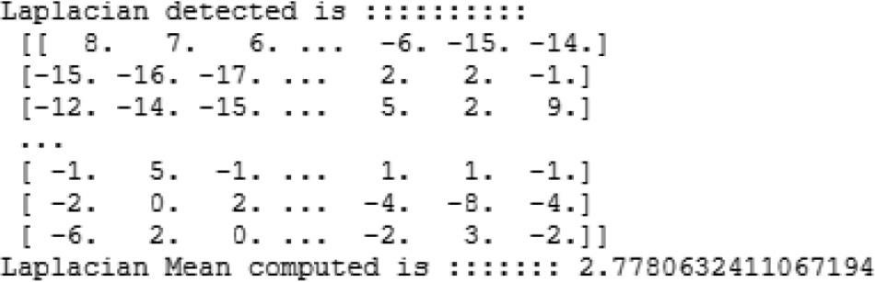

Figure 25: The Laplacian matrix was calculated four times, along with the mean.

The Laplacian edge detection method demonstrated superiority over Sobel edge recognition in the two discussed edge detection matrices. As a result, it was chosen for edge detection in the parking area. However, an increase in misidentified cars within the parking area occurred when employing the Laplacian method. To mitigate this issue, an optimal threshold of 2.7 was applied (Arnott & Inci, 2006b).

# Summary

Efficient traffic management and significant fuel savings can be realized through intelligent parking systems that accurately detect available spots and monitor vehicle arrivals and departures. Utilizing camera image streams eliminates the necessity for extra sensors in parking areas. Our research introduces an innovative vehicle recognition method for detecting vacant parking spaces, employing Faster R-CNN. Furthermore, deep convolutional features are utilized to monitor the count of vehicle entries and exits.

# CHAPTER 6

**CONCLUSION AND RECOMMENDATIONS**

# CONCLUSIONS

The main goal of the project was to develop, evaluate, and refine a predictive model for identifying parking spaces. Utilizing the PKLOT dataset, which contains standardized items, we constructed YOLO and M-RCNN systems to detect vehicle components in parking lots. A custom application was created for this purpose, aiding in organizing parking spaces by marking their coordinates. These coordinates were then used as input for a classifier to determine if each parking slot was occupied. Upon receiving real-time video feeds, the model performed object identification to assess parking space statuses.

To improve the accuracy of the parking detection model, we implemented a motion-detecting algorithm for spaces with uncertain statuses. This algorithm detected moving objects approaching parking spaces and attempted to re-evaluate their status shortly after. This iterative approach significantly enhanced the model's performance, ensuring timely updates to parking space statuses as vehicles entered or exited the lot.

This framework is well-suited for the real-time identification of parking spaces in urban environments, airports, and commercial areas, where there is frequent vehicular traffic entering and exiting parking facilities. The current situation often leads to vehicles circling parking lots, causing time inefficiencies and traffic congestion. Implementation of the proposed strategy in these locations will provide drivers with timely notifications regarding parking availability, empowering them to make informed choices about accessing available spots or exploring other options.

An intelligent parking infrastructure has the capability to substantially diminish fuel consumption and streamline traffic management by precisely monitoring vehicle flow and identifying available parking spaces. The utilization of optical streaming from cameras negates the necessity for supplementary sensors within parking facilities.

In our investigation, we introduced a pioneering technique based on Faster R-CNN for vehicle detection to discern parking spaces. Furthermore, we employed advanced segmentation features to determine the count of vehicle entries and exits. Evaluation using the widely accessible PKLOT dataset showcased an 8% enhancement in precision compared to conventional methods.

Additional research is advised, alongside the deployment of automated systems capable of license plate recognition and payment verification, to ensure precise forecasting regardless of weather conditions. The integration of such technologies will enhance the value proposition for parking management, as it eliminates the need for human surveillance of illegally parked vehicles in urban settings. Notably, the M-RCNN method demonstrated superior efficiency in object recognition compared to the YOLO method. Hence, endeavors to optimize the program's performance for reduced computational resource utilization warrant exploration.

# Contributions

This research enhances existing knowledge by demonstrating the utilization of deep learning algorithms such as YOLO and M-RCNN, alongside classification algorithms, to determine the occupancy status of parking spaces—whether they are available or occupied by vehicles or other objects. The developed prototype showcases the efficient application of AI and machine learning in parking management, resulting in reduced traffic congestion, decreased time spent searching for parking, and enhanced revenue generation in commercial parking facilities through improved data transparency. With a median proficiency of 92.6%, the prototype accurately determines the status of parking spots.

# Future Work

Subsequent studies in this domain should prioritize refining the model's capacity to forecast parking space availability. With a commendable accuracy rate of 92.6%, the developed method shows potential for further enhancement. Integration of an automated artificial parking lot lighting system into the model could ensure precise predictions, particularly during nighttime when vehicles seek access to parking areas. Furthermore, improvements to the model's architecture could involve implementing notification features for customers desiring real-time alerts upon the availability of parking spaces.

# Reference

**CHAPTER 7 REFERENCES**

* + 1. Arnott, R., & Inci, E. (2006a). An integrated model of downtown parking and traffic congestion. Journal of Urban Economics, 60(3), 418–442. <https://doi.org/10.1016/J.JUE.2006.04.004>
    2. **Amato, G., Carrara, F., Falchi, F., Gennaro, C. and Vairo, C. “ Car parking occupancy detection using smart camera networks and Deep Learning,” Computers and Communication (ISCC), 2016 IEEE Symposium.**
    3. Begum.G.K.E.T. (2023) Car Parking Detection System Using Deep Learning. International Journal of Advances in Engineering and Management (IJAEM) Volume 5, Issue 6 June 2023, pp: 850-854
    4. Boda, V.K. & Nasipuri, Asis & Howitt, Ivan. (2007). Design considerations for a wireless sensor network for locating parking spaces. 698 - 703. 10.1109/SECON.2007.342990.
    5. Bui, Q.H.; Suhr, J.K. One-Stage Parking Slot Detection Using Component Linkage and Progressive Assembly. IEEE Intell. Transp. Syst. Mag. (2023)
    6. CNR Parking Dataset - Dataset for visual occupancy detection of parking lots. (2020). Available from: <http://cnrpark.it/>
    7. **Chia-Ying Lin, Yi-Lung Lu, Meng-Hsun Tsai, Hui-Ling Chang (2018). "Utilization-based parking space suggestion in smart city", Consumer Communications & Networking Conference (CCNC) 2018 15th IEEE Annual, pp: 1-6.**
    8. De Almeida, P. R. L., Oliveira, L. S., Britto, A. S., Silva, E. J., & Koerich, A. L. (2015). PKLot-A robust dataset for parking lot classification. Expert Systems with Applications, 42(11), 4937–4949. <https://doi.org/10.1016/J.ESWA.2015.02.009>
    9. Deng, J., Dong, W., Socher, R., Li, L.-J., Kai Li, & Li Fei-Fei. (2010). ImageNet: A large- scale hierarchical image database. 248–255. https://doi.org/10.1109/cvpr.2009.5206848
    10. Everingham, M., Eslami, S. M. A., Van Gool, L., Williams, C. K. I., Winn, J., & Zisserman,

A. (2015). The Pascal Visual Object Classes Challenge: A Retrospective. International Journal of Computer Vision, 111(1), 98–136. <https://doi.org/10.1007/s11263-014-0733-5>

* + 1. Giuseppe Amatoa, F. C. F. F. C. G. C. M. C. V., (2016). Deep Learning for Decentralized Parking Lot Occupancy Detection. Institute of Information Science and Technologies of the National Research Council of Italy (ISTI-CNR), 2(12), pp. 2-6.
    2. Giuseppe Amato, F. C. F. F. C. G. C. V., (2015). A Dataset for Visual Occupancy Detection of Parking Lots. Available at: <http://cnrpark.it/>
    3. **H. Bura, N. Lin, N. Kumar, S. Malekar, S. Nagaraj, and K. Liu,(2018) “An edge based smart parking solution using camera networks and deep learning,” in 2018 IEEE International Conference on Cognitive Computing (ICCC), 2018, pp. 17–24.**
    4. H. Do and J. Y. Choi, Context-based parking slot detection with a realistic dataset, IEEE Access, vol. 8, pp. 171551–171559, 2020, doi:10.1109/ACCESS.2020.3024668 Huang C, S.Y.Y.Z., (2022).
    5. Huang, C.; Yang, S.; Luo, Y.; Wang, Y.; Liu, Z. Visual Detection and Image Processing of Parking Space Based on Deep Learning. Sensors (2022), 22, 6672.
    6. Haji Faraji, P. (2023). Efficient street parking sign detection and recognition using artificial intelligence (T). University of British Columbia. Retrieved from https://open.library.ubc.ca/collections/ubctheses/24/items/1.0437297
    7. Idris, M. Y. I., Leng, Y. Y., Tamil, E. M., Noor, N. M., & Razak, Z. (2009). Car park system: A review of smart parking system and its technology. Information Technology Journal, 8(2), 101–113. <https://doi.org/10.3923/ITJ.2009.101.113>
    8. J. Trivedi, M. S. Devi, and D. Dhara, Canny edge detection based real-time intelligent parking management system, Sci. J. Silesian Univ. Technol. Transp., 106 (2020) 197-208. doi:10.20858/SJSUTST.2020.106.17.
    9. Julien Nyambal,Richard Klein,Hongston shi ,kuchapu kakiku,Automated parking space detection using CNN, International Journal of Advanced research in Science(IJARST),Volume 3,Issue 4,April (2021)
    10. Kher, R. K., & Raninga, P. (2020). Object Detection and Instance Segmentation using Mask R-CNN Algorithm.
    11. Karia.S, Temani.T and Gajara.V (2023), Smart Parking Management System Volume 9, Issue 5, Sept-Oct-2023, ISSN (Online): 2395-566X
    12. Lin, S. F., Chen, Y. Y., & Liu, S. C. (2006). A vision-based parking lot management system. Conference Proceedings - IEEE International Conference on Systems, Man and Cybernetics, 4, 2897–2902. <https://doi.org/10.1109/ICSMC.2006.385314>
    13. Lu, R., Lin, X., Zhu, H., & Shen, X. (2009). SPARK: A new VANET-based smart parking scheme for large parking lots. Proceedings - IEEE INFOCOM, 1413–1421. <https://doi.org/10.1109/INFCOM.2009.5062057>
    14. M. Noor and A. Shrivastava, Automatic parking slot occupancy detection using Laplacian operator and morphological kernel dilation, in (2021) 10th IEEE International Conference on Communication Systems and Network Technologies (CSNT-2021), (2021) 825–831. doi:10.1109/CSNT51715.2021.9509620
    15. Malik, R. G. J. D. T. D. J., (2016). Rich feature hierarchies for accurate object detection and semantic segmentation. Tech Report, pp. 1-4.
    16. O. Barmak and P. Radiuk, Web-based information technology for classifying and interpreting early pneumonia based on fine-tuned convolutional neural network, Computer. Syst. Inf. Technol., 3 1 (2021) 12-18. doi:10.31891/CSIT-2021-3-2
    17. **P. R. de Almeida, L. S. Oliveira, A. S. Britto, E. J. Silva, and A. L. Koerich, “Pklot–a robust dataset for parking lot classification,” Expert Systems with Applications, vol. 42, no. 11, pp. 4937–4949, (2015).**
    18. Ren, S., He, K., Girshick, R., & Sun, J. (2015). Faster R-CNN: Towards Real-Time Object Detection with Region Proposal Networks. <http://arxiv.org/abs/1506.01497>
    19. Truong, L. N. H., Clay, E., Mora, O. E., Cheng, W., Singh, M., & Jia, X. (2023). Rotated Mask Region-Based Convolutional Neural Network Detection for Parking Space Management System. Transportation Research Record, 2677(1), 1564-1581. https://doi.org/10.1177/03611981221105066
    20. Simonyan, K. Z. A., (2019). Very deep convolutional networks for large-scale image recognition. https://arxiv.org/abs/1409

27. Sensors 2022, 22(17), 6672; https://doi.org/10.3390/s22176672

1. Uma Sekaran, R. B., (2016). Business, Research Methods for Business. West Sussex: Wiley.
2. ucheng guo, Hongston shi ,kuchapu kakiku, Automated parking system based on improved neural network, International Journal of Advanced research in Science(IJARST),Volume 3,Issue 4,June 2021.
3. Vijay Paidi, H. F. G. N., (2019). Deep learning-based vehicle occupancy detection in an open parking lot using thermal camera. The Institute of Engineering and Technology, 14(10), pp. 1296-1299 <https://doi.org/10.1049/iet-its.2019.0468>
4. Zanella, A., Bui, N., Castellani, A., Vangelista, L., & Zorzi, M. (2014). Internet of things for smart cities. IEEE Internet of Things Journal, 1(1), 22–32. <https://doi.org/10.1109/JIOT.2014.2306328>.
5. Z. Xu, X. Tang, C. Ma and R. Zhang, "Research on Parking Space Detection and Prediction Model Based on CNN-LSTM," in IEEE Access, vol. 12, pp. 30085-30100, 2024, doi: 10.1109/ACCESS.2024.3368521. Zinelli, A.; Musto, L.; Pizzati, F. A Deep-Learning Approach for Parking Slot Detection on Surround-View Images. In Proceedings of the (2019) IEEE Intelligent Vehicles Symposium (IV), Paris, France, 9–12 June 2019; pp. 683– 688

# APPENDIX A: RESEARCH PLAN

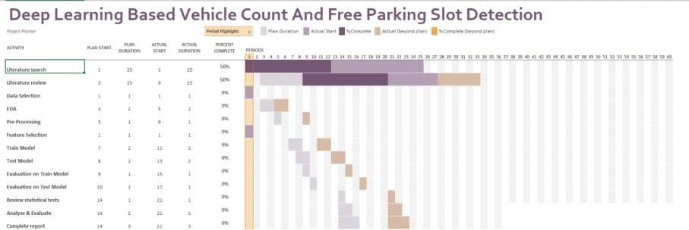

**APPENDIX B: RESEARCH PROPOSAL**

# Abstract

Intelligent parking systems are designed to reduce fuel consumption and enhance traffic management by accurately monitoring vehicle entries, exits, and identifying unoccupied parking spots. Leveraging optical streams from cameras eliminates the need for additional sensors in parking areas. We propose a novel technique based on Faster R-CNN to identify and detect vehicles, specifically aimed at identifying spaces for parking. Deep segmentation features are employed to precisely compute the number of automobile entries and exits. Evaluation on the PKLOT dataset demonstrates an 8% increase in precision compared to previous methods. This innovative approach holds promise to create a more efficient and resource-conscious intelligent parking infrastructure.

**Table of Contents**

Abstract 2

LIST OF FIGURES 4

1. Background 5
2. Problem Statement 6
   1. Related Research 7
3. Research Questions 8
4. Aim and Objectives 8
5. Significance of Study 9
6. Scope of the Study 9
7. Research Methodology 10
   1. Data Description 10
   2. Research Workflow 10
   3. Data Processing 12
      1. Training Set 12
      2. Validation Set and Validation Split 12
      3. Fine-Tuning 12
      4. Test Set 12
      5. Model's Overall Accuracy 12
      6. Data Augmentation and Transformation 12
      7. Data shuffling 12
   4. Evaluation Metrics 13
8. Requirement Resources 14
   1. Hardware requirements 14
   2. Software requirements 14
9. Research Plan 15

References 16

# LIST OF FIGURES

Figure 7.1 Process Flow 8

# Background

Time and finances stand out as the two most significant aspects of an individual's daily life, irrespective of their professional domain. Technological innovation offers the potential to effectively manage both these crucial variables. The escalating global population has spurred rapid urbanization in nations worldwide, transforming rural areas into bustling cities. As per findings from a survey by Our World in Data, metropolitan areas currently accommodate 50% of the world's population. However, the concept of smart cities is still in their infancy, lacking sufficient development to cope with the swift urbanization demands for accessible amenities such as dining, shopping, entertainment, and sports.

In major cities, there is a shared preference among residents for a centralized hub that caters to all necessary extracurricular activities. Strategic placement of businesses in key locations within shopping centers becomes essential, capturing customers' attention and potentially boosting sales. Presently, shopping centers offer a range of services, including banks, food courts, leisure facilities, movie theaters, and playgrounds, consolidating various services in one central area to address the diverse needs of visitors.

The availability of sufficient parking space is a critical consideration, especially for gatherings involving people from diverse geographical backgrounds. Adequate parking is crucial for personal vehicles, and shopping centers often provide parking spaces. The swift, secure, and reliable availability of parking spaces is directly correlated with increased customer frequency and spending, making it more convenient for drivers to locate available parking spaces. The management of vehicles and parking is facilitated by the size of the parking lot, allowing workers to easily identify unoccupied spots.

The implementation of parking vacant detection techniques serves various purposes, including autonomous automobile parking, traffic alleviation through quicker identification of available parking spaces, and optimization of customer parking space allocation. Contemporary algorithms utilize typical machine learning techniques to segregate parking lots, with sensors being a prevalent method in literature to locate open parking spaces. Some studies employ Support Vector Machines (SVM) and background removal methods to categorize patches as either empty or occupied. The recent trend involves an increased reliance on deep convolution neural networks, capitalizing on deep learning breakthroughs in recent years. Proposing a straightforward resolution, the use of object detection techniques within deep learning holds promise for the development of practical and intelligent bay infrastructure.

# Problem Statement

In the last ten years, there has been a substantial increase in private car ownership on a global scale. In spite of progress in technology, cities worldwide are grappling with insufficient infrastructure and parking availability, leading to heavy traffic, congested roads, pollution, and accidents. The scarcity of parking spaces is often overlooked, overshadowed by other urban challenges. Limited parking contributes to the ongoing issues of traffic congestion and environmental concerns.

The rise in businesses offering transportation services at flexible times has perpetuated the routine use of personal automobiles for daily commuting. This reliance emphasizes the need for strategically placed parking structures in areas with high traffic flow. The swift expansion of urban populations in the past two decades has prompted a heightened interest in the exploration of smart parking systems, aiming to mitigate the escalating challenges associated with traffic congestion.

Contemporary communication and information engineering methodologies offer prospects for disseminating real-time parking space information, thereby enhancing accessibility for motorists. Additionally, fast rides or ride-division services have emerged as alternative transportation options, albeit with specific restrictions tied to accessibility.

The presence of appropriate, secure, and well-managed parking spaces significantly influences consumer behavior, leading to increased business patronage. Smart technologies, such as exposure associations in parking management, can optimize parking for workers, reduce transportation time spent searching for spots, and accommodate autonomous vehicles and robotic parking solutions.

While contemporary methods like image segmentation and Convolutional Neural Networks (CNNs) have been employed for identification parking area, challenges persist, especially in less-than-ideal conditions like low-light situations. Notably, the work of Amato and Carrara (2020) introduced innovative image segmentation and CNN techniques to detect open parking spaces.

Despite these efforts, there is a continued need for improvement in parking space detection. This research aims to discuss the challenges associated with exposure in various scenarios, contributing to enhanced parking management systems and urban transportation efficiency.

# Related Research

* + 1. (Hamada et al., 2015; Lee and Seo, 2016; Lee et al., 2016). A method based on lines initially identifies markings of parking slots in the image, then clusters and fits the straight lines, and creates parking spaces using geometric information from the parking slots. However, this line-based approach lacks the capability to differentiate between several types of parking slots, such as parallel, vertical, and slanted parking spaces.
    2. (L. Zhang et al. 2017) discussed Vision based Parking Slot Detection System using DCNN-based Approach and A Large-scale Benchmark Dataset. In this study authors recognize uniform color in slot markings. Yet, it had its imperfections, particularly in varying lighting conditions. To refine the precision of parking slot detection, a set of methods based on lines has been suggested.
    3. (Li and Zhao 2018) The amalgamation of line and marking point detection for parking slots is implemented to enhance detection performance. Nonetheless, these methods rely on low-level visual features and may lack robustness in challenging environmental conditions.
    4. (G. Khan et al. 2019) discussed Deep-Learning Based Vehicle Count and Free Parking Slot Detection System In this study author is detecting parking spaces through Faster R-CNN. Additionally, the count of vehicle entries and exits is determined through deep convolution features. The system proposed is assessed on the publicly accessible PKLot dataset, achieving an enhanced accuracy of 8% compared to the baseline methodology.
    5. (B. Sairam et al. 2020) discussed Automated Vehicle Parking Slot Detection System. In this study authors solve traffic problems using Deep Learning. The model receives all the first available parking slots in the area and real-time processing is performed on the data to determine if the slots are vacant or occupied by any vehicle and provides information about the empty slots. Besides finding a free parking spot for a vehicle, the model will also find an appropriate parking spot for 2 wheelers. The proposed system has improved robustness with a mask rate over 92.33 % and boundary recognition rate over 98.4 %.

# Research Questions

* 1. How well does R-CNN based technique perform in identifying parking spaces for vehicles?
  2. To what extent does the performance of the R-CNN technique in identifying parking spaces rely on the choice of features and parameters?
  3. Which types of data—such as High-Resolution Images and Videos etc. perform better when using R-CNN technique to detect parking spaces?
  4. How can machine learning algorithms be optimized to accurately classify and differentiate between different types of parking slots, considering factors such as orientation, size, and layout?
  5. In the context of smart city infrastructure, what are the potential societal impacts and challenges associated with the widespread implementation of advanced parking space detection systems?
  6. Can R-CNN technique be used to quickly identify and differentiate between different types of parking slots during emergency travelling to help drivers to get space easily with reducing fuel consumption?

# Aim and Objectives

The principal aim is to suggest an intelligent parking system that utilizes the R-CNN technique to detect car number plates and various types of parking slots.

The subsequent research objectives that are formulated to align with the overarching goal are :

* 1. Utilize R-CNN technique to distinguish between different types of parking slots.
  2. To create a model for available parking spaces that are available in the given area using

the R-CNN technique.

* 1. Evaluate the effectiveness of the proposed methodology and compare its performance against state-of-the-art techniques in the field.
  2. Enumerate the total number of cars within the parking lot.
  3. Implement a system to capture and identify vehicle occupancy within parking bays.

# Significance of Study

Locating a parking area for your car in large metropolises can pose a significant challenge due to the increased private automobiles. The demand for parking has outstripped the available supply, creating an imbalance. Given the current scenario in major cities, there is a crucial need for the implementation of a parking management system capable of effectively monitoring parking spaces. This system should encompass essential features such as scalability, efficiency, reliability, and affordability to address the prevailing conditions.

* This approach improves citizen services by effectively managing and reducing on-street parking.
* Furthermore, it advocates enhanced urban planning and decreased transportation congestion.
* Minimizes the effort exerted by drivers and saves time by facilitating secure parking in designated locations.
* For improving safety by reducing traffic-related incidents associated with parking difficulties, promoting smoother traffic flow.
* Optimized parking systems lead to reduced traffic congestion and idling, ultimately contributing to lower emissions and a greener urban environment.

# Scope of the Study

The research will encompass pre-processing procedures aimed at readying the data for clustering analysis, involving tasks such as data cleaning, normalization, and feature extraction. The application of the R-CNN will be implemented to identify and differentiate vehicles from other objects in parking areas under diverse lighting conditions and weather circumstances. The research will explore the use of different clustering configurations to optimize the overall effectiveness of the algorithm.

The study will employ standard evaluation metrics, including accuracy, sensitivity, specificity, and the F1 score, to assess the effectiveness of the proposed strategy (Yelpale et al., 2022). Additionally, there will be a comparative analysis of the strategy's performance against current state-of-the-art methods for detecting car number plates and distinguishing various types of parking slots.

# Research Methodology

# Data Description

The PKLot dataset comprises 12,416 images captured from surveillance camera frames depicting various parking lots. These images include diverse weather situations, ranging from bright and sunny to overcast and rainy days with parking spaces annotated as either occupied or empty. To enhance compatibility, the initial annotations in rotated rectangle format have been transformed into various standard object detection formats, with bounding boxes encapsulating the original annotations.

# Research Workflow

Figure 7.1: Process Flow

Below is an explanation of the research workflow for developing a deep-learning-based system for vehicle count and free parking slot detection.

* + 1. Gather a comprehensive dataset for training and evaluation. Access Kaggle or other relevant sources to acquire a dataset suitable for vehicle and parking slot detection.
    2. Prepare the collected data for modeling by dividing it into training and validation sets, applying data augmentation techniques for increased variability, transforming the data to align with the selected deep learning model's requirements, and shuffling the dataset to enhance model training.
    3. Select a suitable deep learning model architecture, such as Faster R-CNN, YOLO, or SSD, based on the specific requirements of the application.
    4. Train the chosen model with preprocessed training data, assess its performance on the validation set, and refine the model based on evaluation results.
    5. Implement the trained model for real-time processing, leveraging it to count vehicles, detect parking slot occupancy, and generate instantaneous output reflecting vehicle counts and parking slot availability.
    6. Create and deploy a user-friendly interface that allows users to access real-time information, ensuring it delivers clear and intuitive visualizations of vehicle counts and parking slot availability.
    7. Continuously monitoring the system's real-world performance involves assessing accuracy, processing speed, and adaptability to diverse conditions to ensure optimal functionality.

# Data Processing

# Training Set

The training set is used to train the machine learning model. The model learns patterns and features from this set of labeled data.

# Validation Set and Validation Split

During the training phase, the validation set plays a crucial role in fine-tuning the model and preventing overfitting. By assessing the model's performance on data, it has not seen during training, you can adjust hyperparameters or detect signs of overfitting. The training set is commonly split into two components: the primary training set and a validation set. This split is typically done for an acceptable ratio (e.g., 80% for training and 20% for validation).

# Fine-Tuning:

Fine-tuning involves adjusting the model's hyperparameters based on its performance on the validation set. This iterative process helps improve the model's generalization ability.

# Test Set:

The test set is a separate dataset that the model has not seen during training or validation. It is reserved for evaluating the model's performance after training is complete.

# Model's Overall Accuracy:

The test set provides an unbiased evaluation of the model's performance. By assessing accuracy and other metrics on the test set, you can gauge how well the model is expected to perform on new, unseen data.

# Data Augmentation and Transformation:

To effectively enhance the training dataset, it is essential to apply appropriate data transformation techniques, such as image flipping and rotation. These procedures aim to increase dataset diversity. After modifying the images, they are converted into tensors for further processing and to meet the requirements of building and training the model.

# Data shuffling:

At the conclusion of each epoch, the training data is shuffled randomly, ensuring that the batches in subsequent epochs are unique. This practice reduces variance and promotes the development of models that are more generalized and less prone to overfitting.

# Evaluation Metrics

Evaluation metrics include Accuracy, Sensitivity, Specificity. The definitions of these measures are outlined as follows:

* **True-Positive (TP):** It correctly detects the presence of a parking space.
* **True-Negative (TN):** It accurately identifies the absence of parking space.
* **False-Positive (FP):** It suggests a parking space is present when it is not.
* **False-Negative (FN):** It indicates no parking space when there actually is.

Consistency between the model's results and actual conditions is achieved when both True Positives and True Negatives are present. Errors in the model's predictions occur with False Positives and False Negatives.

The formulas for key evaluation measures are as follows:

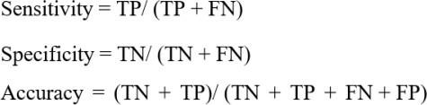

# Requirement Resources

# Hardware requirements

Hardware Requirements for a Computer System with 500GB Storage:

# Storage:

Minimum: 500GB storage space

# Processor:

Minimum: Quad-core processor

# RAM (Memory):

Minimum: 16GB RAM

# Additional Considerations:

A powerful processor (quad-core or higher) ensures efficient performance for various tasks. Adequate RAM (16GB or more) allows for smooth multitasking and handling of large datasets or applications.

# Software requirements

* + - **Programming Language:** Python is commonly used for deep learning tasks.
    - **Deep Learning Libraries:** TensorFlow, PyTorch

# Computer Vision Libraries: OpenCV

* + - **User Interface:** Flask, Django (for web-based applications), or a suitable GUI framework.

# Considerations:

* + - * Hardware Requirements: Depending on the scale of deployment, consider the hardware requirements for model inference.
      * Privacy and Security: Ensure that the system adheres to privacy and security standards, especially if it involves processing video feeds.

# Research Plan

The diagram delineates a 23-week research schedule, encompassing activities from literature review to model implementation, culminating in the final report. The plan dissects the process into 16 unique phases, commencing with the initial stage. Following this, the model will undergo scrutiny and evaluation, culminating in a performance assessment and the ultimate completion of the final report.

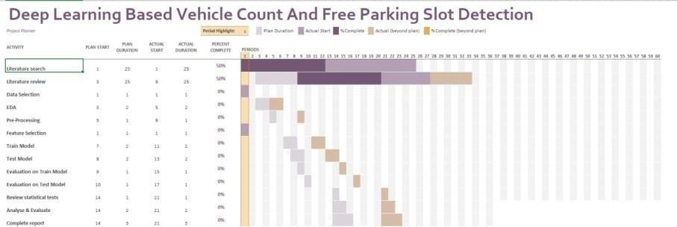

Gantt Chart: Week by Week Plan

# References

# H. Bura, N. Lin, N. Kumar, S. Malekar, S. Nagaraj, and K. Liu, “An edge based smart parking solution using camera networks and deep learning,” in 2018 IEEE International Conference on Cognitive Computing (ICCC), 2018, pp. 17–24.

Arnott, R., & Inci, E. (2006a). An integrated model of downtown parking and traffic congestion. Journal of Urban Economics, 60(3), 418–442. <https://doi.org/10.1016/J.JUE.2006.04.004>

Arnott, R., & Inci, E. (2006b). An integrated model of downtown parking and traffic congestion. Journal of Urban Economics, 60(3), 418–442. <https://doi.org/10.1016/J.JUE.2006.04.004>

Boda, V. K., Nasipuri, A., & Howitt, I. (n.d.). Design Considerations for a Wireless Sensor Network for Locating Parking Spaces.

De Almeida, P. R. L., Oliveira, L. S., Britto, A. S., Silva, E. J., & Koerich, A. L. (2015). PKLot-A robust dataset for parking lot classification. Expert Systems with Applications, 42(11), 4937–4949. <https://doi.org/10.1016/J.ESWA.2015.02.009>

Deng, J., Dong, W., Socher, R., Li, L.-J., Kai Li, & Li Fei-Fei. (2010). ImageNet: A large-scale hierarchical image database. 248–255. <https://doi.org/10.1109/cvpr.2009.5206848>

Everingham, M., Eslami, S. M. A., Van Gool, L., Williams, C. K. I., Winn, J., & Zisserman, A. (2015). The Pascal Visual Object Classes Challenge: A Retrospective. International Journal of Computer Vision, 111(1), 98–136. <https://doi.org/10.1007/s11263-014-0733-5>

Idris, M. Y. I., Leng, Y. Y., Tamil, E. M., Noor, N. M., & Razak, Z. (2009). Car park system: A review of smart parking system and its technology. Information Technology Journal, 8(2), 101–113. <https://doi.org/10.3923/ITJ.2009.101.113>

Kher, R. K., & Raninga, P. (2020). Object Detection and Instance Segmentation using Mask R-CNN Algorithm.

Lin, S. F., Chen, Y. Y., & Liu, S. C. (2006). A vision-based parking lot management system. Conference Proceedings - IEEE International Conference on Systems, Man and Cybernetics, 4, 2897–2902. <https://doi.org/10.1109/ICSMC.2006.385314>

Lu, R., Lin, X., Zhu, H., & Shen, X. (2009). SPARK: A new VANET-based smart parking scheme for large parking lots. Proceedings - IEEE INFOCOM, 1413–1421. <https://doi.org/10.1109/INFCOM.2009.5062057>

Ren, S., He, K., Girshick, R., & Sun, J. (2015). Faster R-CNN: Towards Real-Time Object Detection with Region Proposal Networks. <http://arxiv.org/abs/1506.01497>

Zanella, A., Bui, N., Castellani, A., Vangelista, L., & Zorzi, M. (2014). Internet of things for smart cities. IEEE Internet of Things Journal, 1(1), 22–32. https://doi.org/10.1109/JIOT.2014.2306328